reachingaprisoner.com
Hello There!

Danielle L. Johnson DOC#81026 Jean Conservation Camp P.O. Box 19859 Jean, Nevada 89019
Gender: Female
Ethnic Background: Mixed
Height: 5ft. 7in.
Weight: 170lbs.
Hair Color: Dark Brown
Eye Color: Dark Brown
Expected Release: 1/9/2021
Looking to Write: Men
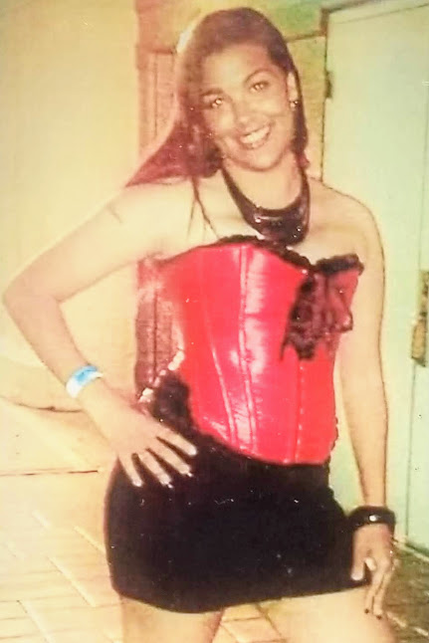

My name is Danielle. I am a 35-year-old sophisticated and well-mannered lady who appreciates a man who is willing to engage in a deep intellectual conversation about almost anything. I enjoy discussing current events, religion, music, dining, art, traveling, sports and much more. I appreciate someone who can stimulate my mind and open my eyes to look at things a new way. I’m rather quiet and reserved, open-minded, confident, non-judgmental, humorist and empathetic. I am easy going but I can be rather serious at times. I love life, humor and I love to laugh. I’m convinced it’s one of God’s many given means to help us though life. I take great interest in others, so I do hope you choose to share your friendship with me. It’s something I look forward to!
