reachingaprisoner.com
Hi, my name is Tyheem and I’m looking to meet new people for friendship and correspondence. I’m also looking for love if that is possible. Whatever happens I’m all for it. Looking to get to know someone and see where it goes. I don’t have much time left. I get out in less than a year. I’m a black man from Brooklyn, Ny. I’m a twin with my sister. For fun, I love to play and watch sports, play pool, bowling, video games, go to the museum, zoo, amusement parks, out to eat, enjoy the outdoors, long walks, fishing, listening to music, read, write, draw, etc. I love to have fun and know how to have fun. I am also open to trying new things. I’m outgoing and have a great sense of humor. I not here to use or abuse you, nor do I play games. I accomplished many things during my time here. I have over 10 certificates and looking to gain more. I’m doing whatever it takes to avoid coming back here. I’m looking to relocate, sweety. So, I’ll come to you if that’s possible. I’m from NYC if you never been there, I’d love to show you around and keep you company. I have a bis loving family, so don’t be shy and send me a letter today!
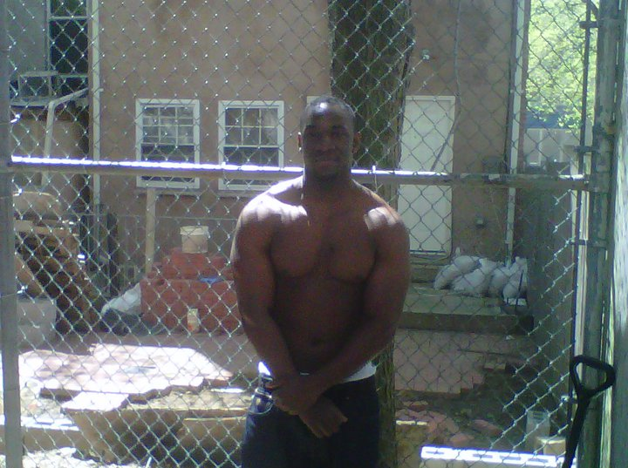
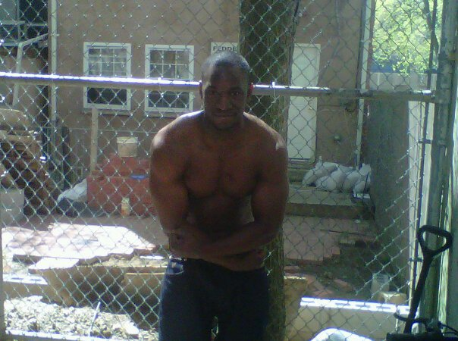

Tyheem Walker DOC#159972 Maine Correctional Center 17 Malison Falls Road Windham, Maine 04062
DOB: 7/30/1984
Gender: Male
Ethnic Background: African American
Height: 6ft
Weight: 240lbs
Hair Color: Black
Eye Color: Brown
Expected Release: June 2020
Sexual Orientation: Straight
Looking to Write: Straight, Lesbian, Bisexual Woman
