reachingaprisoner.com
Hello! I’m Zach. It’s a pleasure to hopefully meet you! I’ve been here 10 ½ years, it’s taught me a lot about myself. I’m in search of true friendship someone I can befriend, tell anything too and be myself. I’m a man who stands on his own two feet, I don’t play games. EVER! I’m honest, loyal and trustful. I believe in family, honesty and loyalty above all else. I love to laugh and have fun, but also be a gentleman and serious I feel there is a time and place for both. I love to draw and shoot tattoos. I love to read (biography, true crime, self help and history). I love music (country and rock)) I love the outdoors (camping, fishing hiking, etc.) I love to travel. I love to exercise. I just love life, it’s to short not to! I’m just a strong, positive, upbeat man. Well I hope you like what you read and hope to hear from you!! Until then stay safe! Write Soon!

Zachary Barfield DOC#A607507 TOCI 2001 E. Central Ave. Toledo, OH 43608
Sexual Orientation: Straight
Looking to Write: ANYONE
Expected Release: 9/17/2049
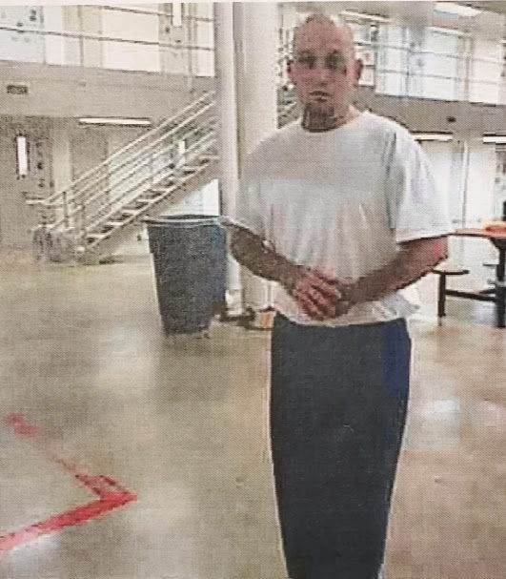

Sincerely,
Zach

