Reachingaprisoner.com

Kevin Hicks DOC#657277 CCA/Core Civic 3200 S. Kings Highway Cushing, Ok 74023
DOB: 6/6/1995
Gender: Male
Ethnic Background: Black
Height: 5ft 11in
Weight: 210lbs.
Hair Color: Black
Eye Color: Brown
Expected Release: 2/26/2032
Sexual Orientation: Straight
Looking to Write: Straight, Lesbian, Bisexual Woman
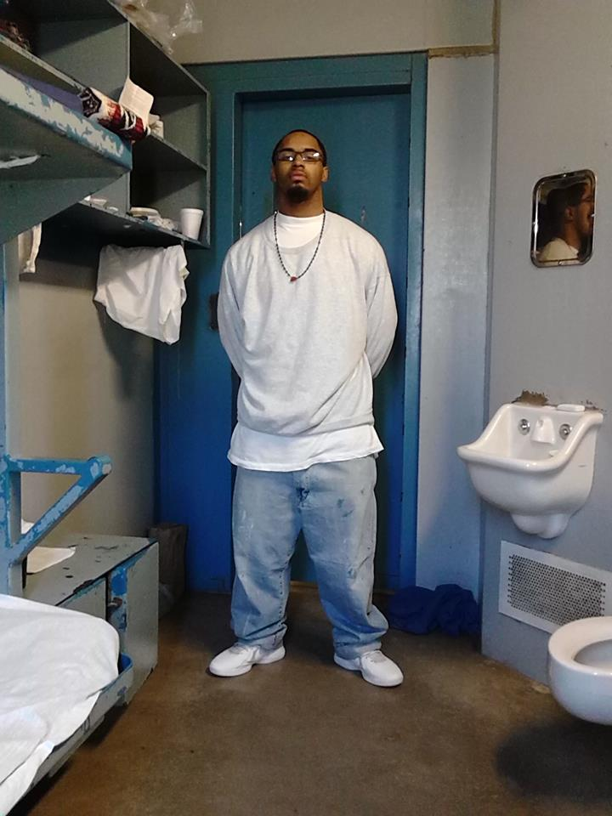

Hi, I’m Kevin and I’m 23 from Tulsa, Ok. I’ve been incarcerated for 7 ½ years. I have 13 years left to do, I’m working on getting my time reduced because I was so young when I got locked up. And since I know God is great, I know he will bless me, so let me tell you about myself. I love to read, work-out, write poems, and do everything to better myself. I love books (any kind), I love to learn, so anything that can teach me, but romances are my favorite. I truly believe in using your mind to grow and become a better person, I don’t have much family out there, most of my family had died since I have been incarcerated. I don’t have any kids even though I would love to have a family someday! I’m looking for a pen pal, someone special and open minded who wouldn’t mind writing and developing a flourishing friendship. I truly believe that friendships should be built on a solid foundation of trust, honestly, respect, appreciation, sincerity, attention, and to compromise. I want a woman who is beautiful on the inside, outer appearances don’t matter to me. I hope to find someone who is smart, driven, passionate, kind and loving. Someone who knows what she wants in life and who isn’t scared to go for it. I’m very intellectual individual and I want someone who can laugh with me, I love to make people smile. To be honest I’m looking for a Queen, a partner, a best friend, and my future wife. Age doesn’t matter to me it’s just a number, it doesn’t make a man a man or a woman a woman. So, if you’re interested in making a good friend and hopefully more, write me! I’m truly putting my heart out there hoping to find a good woman to share my life with, this is not a game for me. I’m sincere with my search for happiness. And I’m truly looking for my soulmate, if it’s you, I hope I find you soon.
See Page 2 for more Pictures

