reachingaprisoner.com

Benjamin Alan Morris DOC#1711366 George Beto IDCJ 1391 FM 3328 Tennessee Colony, Tx 75880
DOB: 01/18/1973
Gender: Male
Ethnic Background: White/ Native American
Height: 6ft 1in
Weight: 230lbs.
Hair Color: Brown/Grey
Eye Color: Green Hazel
Speaks and Writes Spanish
Expected Release: 5/30/2030
Sexual Orientation: Straight
Looking to Write: ANYONE
Has Access to: JPay
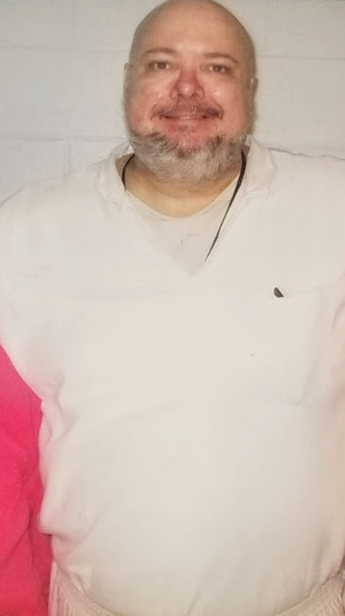

Currently seeking new friends that are positive and creative minded also faith minded people. Would love to find prayer partners and business mentors to help me perfect business ideas and a business plan, also a plan of action upon prison release. Let me clarify, without truth and honesty and openness there is not true friendship. As long-lasting relationships are made on the foundation of truth and honesty, without it, it isn’t worth the time and effort. No games, I‘m playing for keeps.
Before coming to prison, I grew up in a rural central Texas, a country boy at heart. I was in the US Army for 13 years full time and reserves. Iraq war Veteran, college educated, and certified IT specialist and I have worked for several large technology and computer companies.
Some of my hobbies are: I love the outdoor sports, gardening and farming; reading all kinds of books and making artwork; Riding my Harley Davidson motorcycle; cooking (I have taken culinary arts classes); spending quality time with friends and family.
I’m a lover not a fighter, heart as big as Texas, a heart of gold and true as steel. I’m supportive, creative, and a reflective personality spectrum. Always remember a nasty ugly caterpillar transforms into a beautiful butterfly. It is a person’s heart and character that makes a person’s appealable to me.
It’s no secret that prison is a very negative environment and during the holidays a very lonely place to be. No man or women is on an island we ALL need positive interaction with others. Even though I find myself surrounded by negativity, I remain positively focused on my goals and dreams in life. Truly, my time in prison has a journey, a time of reflection of the past, to learn from my mistakes and keep moving. I am man enough to take responsibility for my past and learn from it. I have made a solemn promise to God and myself to never again repeat my past sins and mistakes. I’ll talk to anyone from anywhere worldwide. Senoritas Se Habla Espanol; Escribir Mi Por Favor. I will respond to all letters promptly. If you use Jpay please include your mailing address.
