reachingaprisoner.com
Mr. Allen Robertson, Jr. #168025/DR-B4 LA State Prison Angola, LA 70712
DOB: 7/18/1967
Death Row

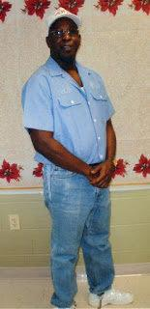

Dear Readers,

Sometimes it's hard to find that true someone to whom you can really connect with. Not just on a personal level but on an emotional level as well. That especially seems to be the case when it comes to my situation.

I mean, it’s tough finding people who are willing to invest themselves, emotionally, in the unknown.....But that's exactly what I'm looking for. Someone to take a chance on me. Not only that but to find the best in me too!

I'm very open minded and I like to enjoy everything that life has to offer. I love to smile and laugh a lot too. A great sense of humor goes a long way! If you would like to learn more about me a few lines to introduce yourself. Who knows maybe I’ll hear from you!

I’m 50 years young, born July 18, 1967. I'm from Baton Rouge, Louisiana, born and raised... I've been on death row for 24 1/2 years. I am a Christian of Baptist faith.

Sincerely yours,

Allen Robertson Jr.

