reachingaprisoner.com
Hello!!!

William Cody Neal DOC#103804 CSP- F4-24 P.O. Box 777 Canon City, CO 81215
DOB: 10/7/1955
Gender: Male
Ethnic Background: Caucasian
Height: 5ft 8in
Weight: 170lbs.
Hair Color: Salt and Pepper
Eye Color: Diamond Blue
Expected Release: Appeal
Sexual Orientation: Straight
Looking to Write: ANYONE
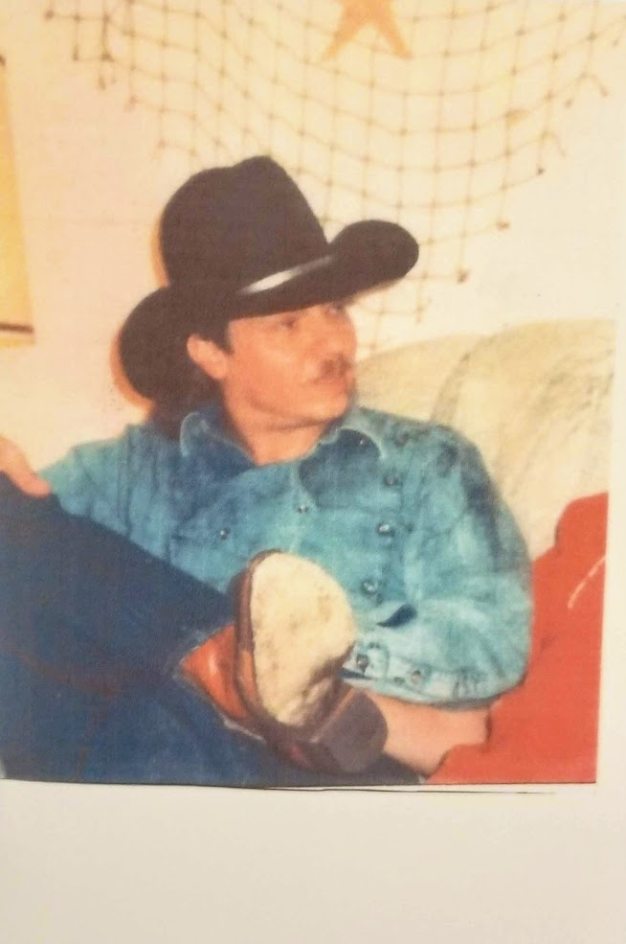

It’s me Cody!!! This “Cowboy” loves “country music” and all the “fixin’s” too!! I enjoy making the ”best” of each new day this wonderful life “offers” and most of all I love meeting new friends, “both adult men and women” pen pals.
I am “very” “open-minded” and “welcome” “all” people from all walks of life, it’s one of my greatest strengths!! Please know no matter who you are, you’ll find a friend in this cowboy!! I know full well what its like to take a fall and I am humbled to have a second chance at life; it only makes me “Love and Appreciate” more “deeply” the “friends” I meet along the way!!
I have many interests!! I love my daughter more than my “pickup truck” that’s big love!! She’s still got me wrapped around her “little” finger!
My “guilty pleasure” is “romance novels and chocolate” and I love the rodeo, bull riding, wild horses, cats and dogs, mountaineering, bird watching, water sports, sailing, scuba diving, skiing, classical music, photography, yoga, wild flowers, travel, learning new things and helping other’s which is my passion.
My favorite animal is a “bear” since I’m a bit of a “cub” myself!!
I’m an “Honorably Discharged” U.S. Army Veteran and served with the U.S. Army, A75th Rangers and while in the U.S. army, I was also taught “mountaineering and wilderness survival”.
Before prison I owned business throughout the USA and while in prison I serve as a “Jail House” lawyer.
I miss my “mother” beyond measure, as I was her “hospice” nurse when she died of “cancer” and three years later I was a broken man heading to prison.
I’m doing my best to honor her, having lived a non-violent life behind these walls since 1998. I sure could use some friends to help me stay on the right path.
I hope to hear from you soon!!!
Your Friend,
Cody
P.S. Please always “include” your “snail mail” address, so I can mail you back ASAP, especially on www.JPay com emails to me. Thank you!!!
