reachingaprisoner.com
Looking for a real Friend?

Richard Paul Madetzke#20415 Mike Durfee State Prison (West 208B) 1412 Wood Street Springfield, SD 57062-2238 www.connectnetwork.com
DOB: 2/23/1979
Gender: Male
Ethnic Background: Caucasian
Height: 6ft
Weight: 170lbs.
Hair Color: Brown
Eye Color: Brown
Expected Release: 10/2025
Sexual Orientation: Straight
Looking to Write: ANYONE
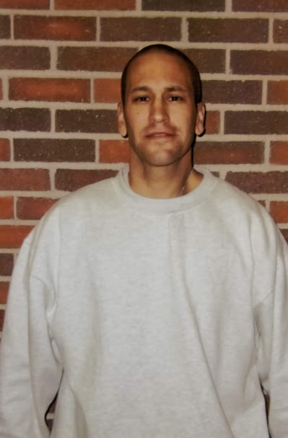

Friends are there when times are good, but when the times get though, most disappear. During my last eight years in prison only a few of my “Friends” remembered me and now I realize who my real “Friends” are. My hope with this is that I find more real “friends” and maybe even find that someone special.
I’m not perfect and I do not expect you to be perfect. I have made some mistakes and have learned from them. I’ll be honest with you so please be honest with me. I won’t judge you so please don’t judge me. Just be real with me and I will be real with you.
I work as a G.E.D. tutor and will soon start the four-year Electrical Apprenticeship course. My degree will help me attain a good paying job as an electrician on work release in 2025. I work out and run to stay in shape. I enjoy a wide variety of foods…except prison food…YUCK! Ha, ha! I also enjoy almost every genre of music, writing, playing, softball, movies, reading, walks, going to the zoo, football and baseball games, concerts, golfing, traveling, camping, fishing, hiking, paintball, bowling, cooking, playing poker, cats and dogs, and hanging and chilling out, to name a few.
If you would like to correspond with me, you must use only white envelopes, white lined paper with blue or black ink or white typing paper (color printing is allowed on white typing paper). Please handwrite your return address (address label stickers are not allowed) Or you can email me at www.connectnetwork.com by searching my name (Richard Madetzke) or number (20415).
Well, that’s a little about me and what I’m looking for. I look forward to hearing from you. If you like my profile and pictures and looking for someone real to write, email, talk to on the phone, or maybe even visit with face to face or online.
Respectfully,
Rich
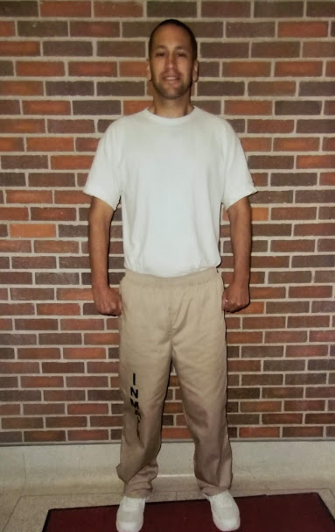
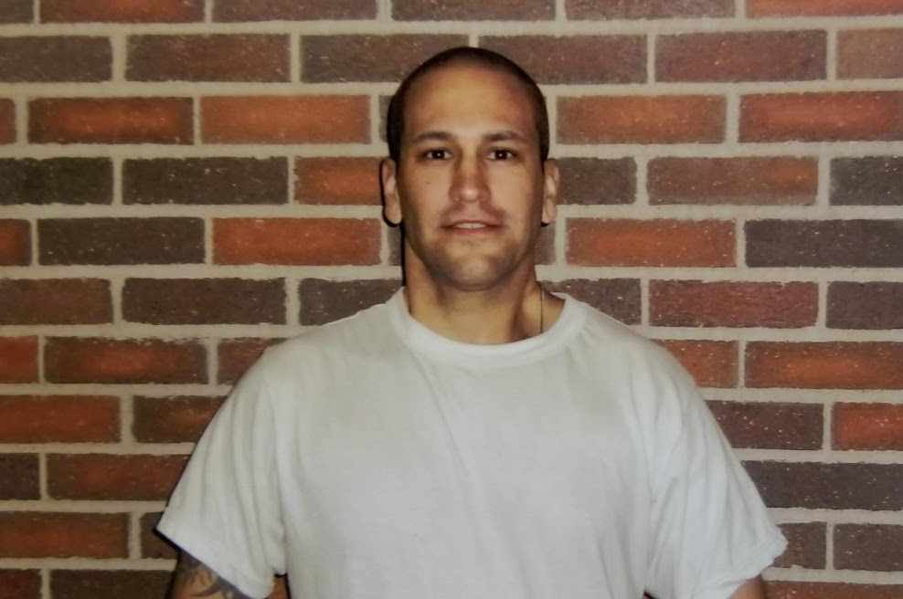

forgiveness
It’s is hard but I must make,
it gives but does not take,
It provides mercy and will not forsake,
It is stronger than hate,
It will not be fake,
It delivers closure in its wake,
It is not a mistake,
It’s what I pray the lord exonerate.

A friend
A friend lets you be you,
A friend grows without growing away from you,
a friend is always there for you,
a friend defines and shapes you,
a friend always respects and never betrays you,
A friend knows your weakness but shows your strenghts to you.

Happiness
Happiness can surprise and give aptitude,
Happiness intrests us in life and connects us through longitude,
Happiness is a place between that inspires our latitude,
Happiness is not what happens to you but to your attitude,
Happiness is the experience of living each moment with gratitude.

Prison Stare
In prison I stare, all the time aware,
not allowed to go anywhere,
someday I will be over there,
always dreaming of going somewhere
Prison Thinking
In prison I think about many sights,
I think about my wrongs and my rights,
I think about the good times and the bad fights,
I think bout the regrets I have from that night,
I think about making better choices with delight,
I think I will have to use all my might,
I think of you seeing a change in me tonight,
I think about prison making me right.

