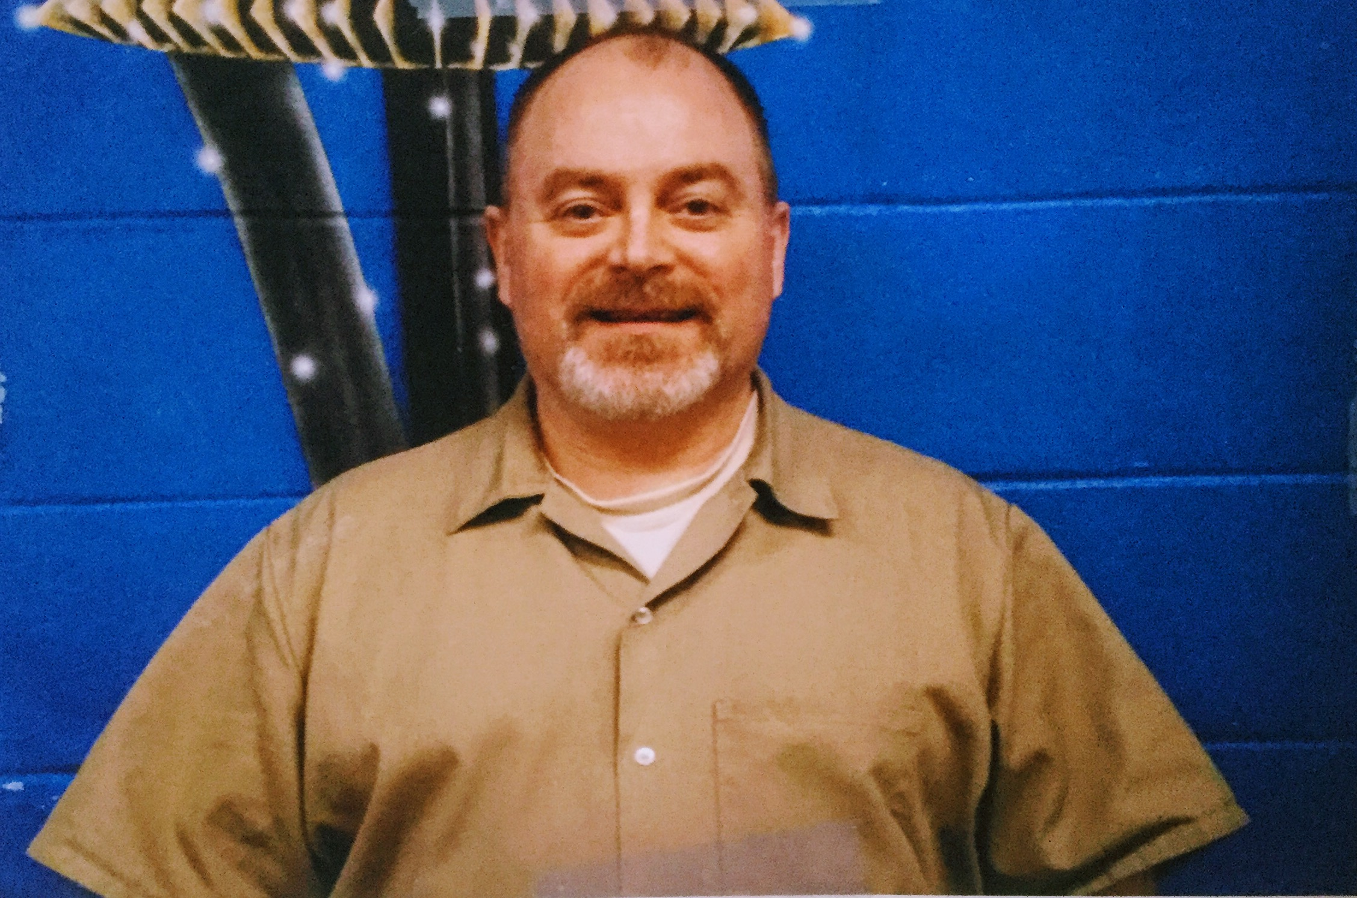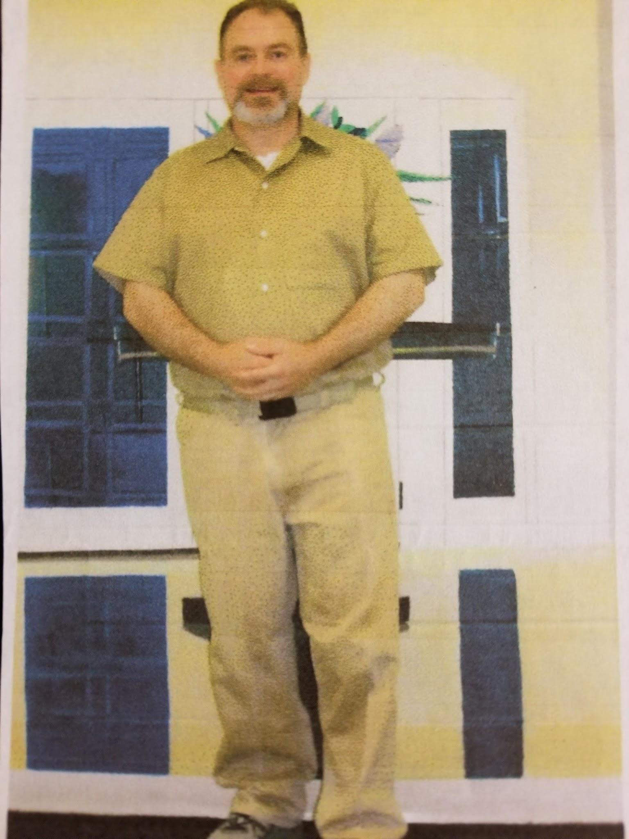
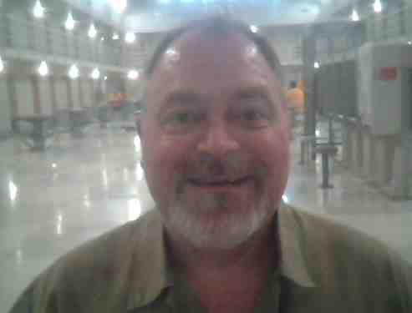

Del Michaelson DOC# 906033
AHCC. - LB44L
PO Box 2049
Airway Heights, WA. 99001

Hi I'm Paul, that's my middle name, I'm 54 years young, I'm an easygoing kind of guy with a great sense of humor, some may say corny.
I am a music lover, a trivia buff and actually enjoy history.
I am exploring my artistic touch I make Jewelry and am learning to play the Guitar.
I was raised in the city but love the outdoors: I fish, camp, hike etc... I enjoy gardening, Green sustainable living, fiddling around the house and cooking, I'm really good at it, if that's what you like then I'm your guy.

I love to learn, I read a lot, mostly mysteries, noir and gumshoe thrillers, some Bio's and self help.I am a positive and supporting friend, I am spiritual and value my connection with my higher power.I am looking for someone with similar interests, someone who is willing to take a chance and take time to get to know me. Someone who is not afraid to open up and let me get to know them.

Since my incarceration, I've been working on my mind, spirit, body and soul, I love to learn and grow. I'm hoping to find someone who wants to share, who wants to know how I'm doing, how my day is, what's going on in here and someone who can lean on me as well. so, if you enjoy writing me, you may ask me anything you would like. I like all kinds of people, from everywhere in the world. Maybe we can put a smile on each others faces and bring joy into each other's day.

Thank you, I hope to hear from you soon.
Del Michaelson. 906033
AHCC. - LB44L
PO Box 2049
Airway Heights, WA. 99001

