reachingaprisoner.com
My name is Marcus “Todd” Drake. I go by Todd, however, since I am an inmate in a state facility. I use my name, mainly for mail. I am currently incarcerated ay El Dorado Correctional Facility in El Dorado, Kansas. I started this profile at Reaching A Prisoner in hopes of finding and communicating with the members of the opposite sex. I will write back to any and all who get in touch with me. If we connect, I will tell you much more about myself, but since I’m limited to 350 words, I will keep it short and sweet.
Marcus Todd Drake DOC#118626 El Dorado Correctional Facility EL-208 P.O. Box 311 El Dorado, Kansas 67042
DOB: 3/8/1972
Ethnic Background: Caucasian
Height: 6ft. 1in.
Weight: 220lbs.
Hair Color: Blonde
Eye Color: Blue
Expected Release: Sept. 20220
Sexual Orientation: Straight
Looking to Write: ANYONE
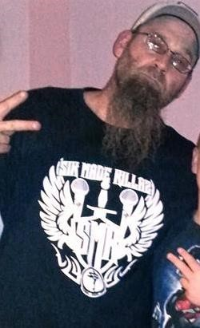

Like most inmates, I am an avid reader. One of my favorite author’s is Terry Pratchett, closely followed by Tim Dorsey, Christopher Moore, and Carl Hiaasen. If you are familiar with any of these fellas, then know they are very witty and intelligent writers. I am a huge fan of underground music. Mostly very heavy-metal and a lot of underground Rap, as well. Horrorcore to be more specific.
I am taking a correspondence course at Blackstone Career Institute, where I am working to become a certified Paralegal/ Legal Assistant. As of March, of this year, I have a little less than two (2) years left to serve. I will probably have to stay in, or around the Wichita, Kansas area for six (6) months to (1) one year after I am released. That depends on me getting my fines and restitution paid off and making sure I report to my post-release officer. (LOL) I am hoping to meet someone who enjoys writing letters, telling jokes, laughing, and enjoys life overall. I have grownup a lot in the last three years that I have been incarcerated. I feel that I have a lot to offer society and a lot to offer a person on a one-on-one basis as well.
If you are interested in getting to know me better, please do not hesitate to write me. I am fifteen (15) words away from my 350-word limit. Apparently, I nailed it.
