reachingaprisoner.com

Bernardo Gomez DOC#116993
Eyman S.M.U. One
P.O. Box 4000
Florence, AZ 85132

DOB: 3/19/1984
Height: 5ft. 11in.
Weight: 210lbs.
Eye Color: Brown
Hair Color: Brown
Race: Mexican American
Expected Release Date: 5/20/2026
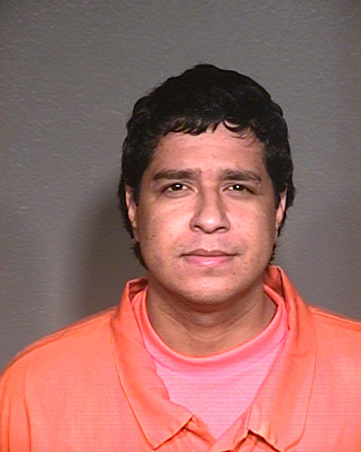

Hello my new Friends,

Thank you for taking the time to read my profile. I don’t have a picture as of yet, but in time there will be one. My name is Bernardo Gomez and I am 33 years old. I am 5’11 with brown eyes and 210 pounds. My birthday is March 19, 1984. I was born in Phoenix, Arizona but raised in Eloy, AZ.

I am serving a 12-year sentence for kidnaping. I have given my life to God. God is my best friend and my Judge. I thank him for everything that I have. I would like to write someone who is also a Christian. Male or Female doesn’t matter. Whoever should take the time to write I will be open and honest.

I like to read, watch sports, and all animals. Thank you for reading my profile and hope to hear from you soon.

Bernardo

