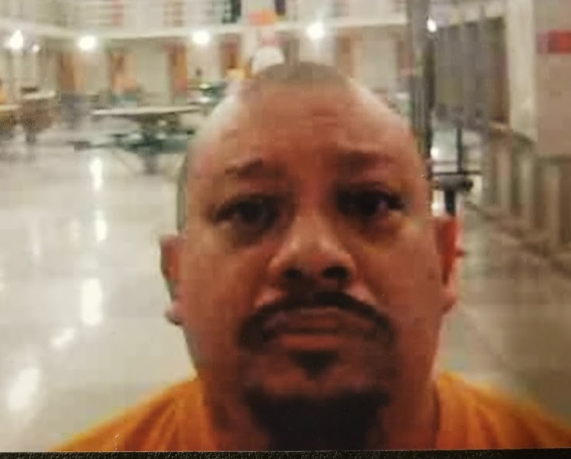

Joseluis Aguilar DOC#825397
ACHH LB-16-Lower
PO Box 2049
Airway Heights, WA 99001

What’s up my name is Joseluis, and I am currently in Airway Heights, WA. I am 100% Mexican, but raised in California. I am 5 foot 4 inches and 180 pounds solid. I’m looking for a pen pal, someone who doesn’t play games, cause I’m not about games. I am a good artist, and I like to draw. I got a lot more to say if you are interested. Write me a few lines and I’ll write you back.

Thank you,

Joseluis

You can reach me by mail or JPay.com

