reachingaprisoner.com
Wuts up

Leroy Arista DOC#01882079 McConnell Unit 3001 S. Emily Drive Beeville, TX 78102
DOB: 6/2/1987
Gender: Male
Ethnic Background: Hispanic
Height: 5ft. 6in.
Weight: 155lbs.
Writes and Speaks: Spanish and English
Sexual Orientation: Straight
Looking to Write: Woman
Has Access to: JPAY

Name is Leroy Arista, I’m 31 years young. I’ve been locked up since 2011. I’m looking for someone I could connect with mentally, maybe even emotionally. Someone who wouldn’t mind walking along side me as I journey through this life of metal bars, wire fences and concrete walls, I’ve made some poor choices when I was younger and now I’m paying for them with my life. I’ve changed my mentality and outlook on life throughout the eight years in this Texas prison. I know I would be a different person if I were ever given the chance to walk out of here. What helps pass the years is my passion for art. To some people art is a hobby to me, it’s a life style. My mind, body and soul are painted by my experiences and unconditional love for my family and my Mexican culture. I’m a graffiti artist at heart so I bleed paint, exhale aerosol and I’m saturated with ink from the tattoos that have engulfed my body. Six words that best describe me are artistic, creative, charming, loyal, and deep, always workout to stay fit and ready. I try my best to stay out of trouble. Sometimes that’s very hard to do around here; in fact, it’s almost impossible. I like to stay positive; I try to see the brighter side of all situations, even after receiving all this time, I’m relatively always walking around smiling, laughing and joking around with people. Negative energy always brings negative responses. I like to read as well, I’ve read countless books of James Rollins, I like the way he mixes history with a twist of fiction. I’ve read some self-help books and studied American Sign Language in the free world and while inside these penitentiary walls. I’m currently studying Nauhatl, an uto Aztec language that’s still spoken by many people in remote areas in Mexico and in Central America. If anyone would like to get to know me better, shoot me a kite, I don’t bite….I think…I’m here all day every day…. Laters
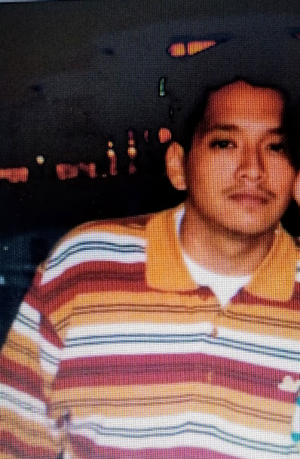

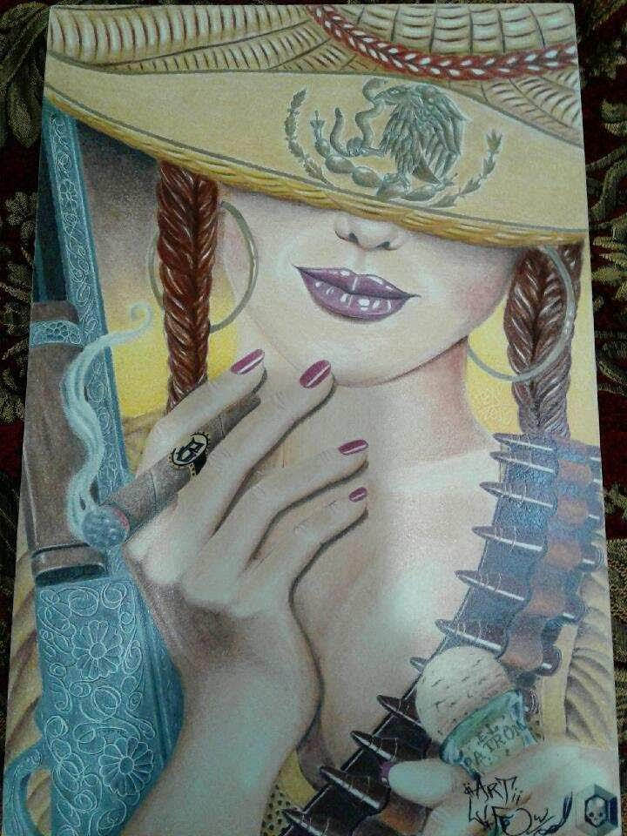
ArtLife
What is ArtLife?

It’s when one lives an artistic life style, day in and day out. When you see your neighbors newly vandalized wall or fence and you admire the shadowy artists’ work.
When you consider graffiti an art not a crime!! when you can’t go one day without doing a piece of art using some type of medium whether its graphite, pen, markers color pencils, charcoal, pastel, oil paint, spray paint!!
When you read not one word of the magazine, but see a million ideas for the next board, your next canvas…..
It’s when you toss & turn in your bunk at night cuz you just thought of a bad ass concept for your next board.
When you eat, when you breath, when you bleed……..paint!!
It’s like a mosquito with a spray can attached to its ass jus bite you & it won’t stop itching & it keeps itching..
It starts infecting your brain till all you think about is your next black book page, your next painting, your next illegally spray painted wall, your next……..Master piece…..
You live that life when you feel there’s not enough time in the day to finish a project…

I live that life, the difference is --- I live an Art Life Without …….the possibility of parole and I will never step foot out of this……………..Art Life!!!!!!!!!

