reachingaprisoner.com
Thanks for stopping by to spend this time with me. First and foremost, I want to say that I can assure you I won’t be a waste of your time. Why can I say that??? Well…..what can I say I’m funny, down to earth, big hearted, loyal, honest, and not to mention good looking…

Robert Barros DOC#147215 C.U.C.F. Gale-C-20 P.O. Box 550 Gunnison, UT 84634
DOB: 7/6/1981
Gender: Male
Ethnic Background: Hispanic/White
Height: 5ft. 9in.
Weight: 220lbs.
Hair Color: Brown/Black
Eye Color: Brown
Expected Release: Jan. 2020
Sexual Orientation: Straight
Willing to Write: Woman
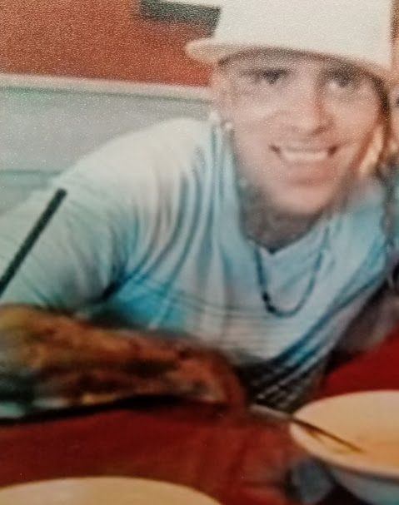

I’m a great friend when I’m given that opportunity and new friends is what I’m hoping to gain. I’m looking for people who are willing to be here with me for who I am today.
Everyday I’m working towards being a better man. I’m doing everything in my power to be productive in here. I’m learning a trade. I work in a metal shop. We make signs, highway signs, street signs, stop signs, etc. etc.. The art is creative in a art room on a graphic design program and after we go step by step until the product is ready to be shipped to it’s customer other than that I work I take classes for marketing. I’m learning business through the stock market. A whole new hustle! I’m also in a program that allows me to attend multiple self-help classes. My environment is pretty positive considering my situation, a choice I chose to make for. Outside of that I work out, I play sports I draw, and I love music; rap, hip hop, R&B, country, pop, soul and funk.
I come from a tight family and we’re all pretty close. I don’t have any kids, but hopefully someday that will happen. I also hope that somewhere along this letter I’ve caught your attention enough to write back. Please feel free to ask me anything that will help you understand me better. I promise to be open, honest and sincere all the way through. Till next time, be blessed and take care! I’m looking forward to hear from you……
Sincerely,
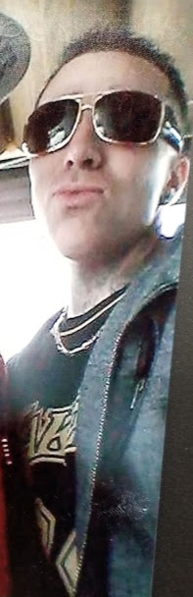
Robert
