reachingaprisoner.com

Carey Ann Lucas DOC#325514 West Tennessee State Prison 480 Green Chapel Road Henning, TN 38041
DOB: 11/05/1981
Gender: Female
Ethnic Background: Caucasian/ White
Height: 5ft 7in
Hair Color: Brown
Eye Color: Brown
Expected Release: 2/2020
Looking to Write: ANYONE Male
Has access to JPay
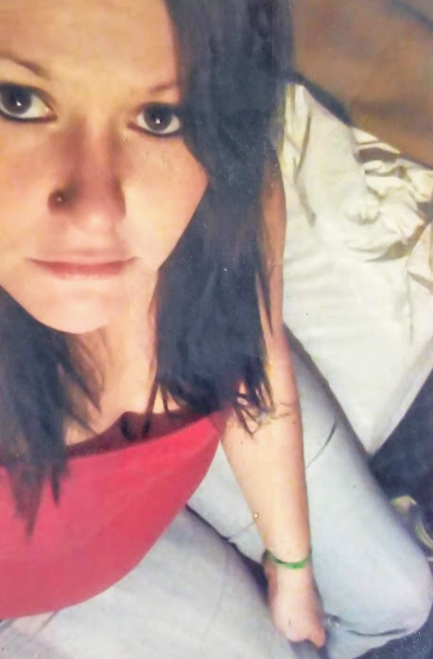

Hello,
I’m Carey. I’m 37 years old with long brown hair, dark brown eyes and I’m 5ft 7in tall.
I am currently in search of someone serious to get to know and spend my time with. I enjoy the outdoors, music, traveling, being a housewife, and football. I’m very open-minded and outgoing. I’m a computer/phone geek and I’m also a kid at heart, as I still love video games and X-Box.
I am single with no ties to anyone. I am looking/wanting to an entirely new fresh start upon my release and I am completely and most definitely ready and willing to relocate. I’m searching for love, companionship, trust, and commitment. I want to find happiness and turn my life around. Someone who isn’t afraid to show their emotions and who will treat me with lots of TLC, spoil me, give their time and attention, and give me lots of affection, honor, respect and love.
I want someone not afraid on taking a chance on someone who will stand with me until I am able to get released and not be judgmental because of where I currently am. I want someone who will love hard but be gentle. I simply want someone willing to take me away from here and give me a brand-new life.
I sincerely hope we can become friends and so much more. Write to me. I would love to hear from you. I also have email access through JPay.

