reachingaprisoner.com
Hello,
James Edward Dailey DOC# T-32925 VSP D1-23-3L P.O. Box 92 Chowchilla, CA 93610
DOB: 1965
Gender: Male
Race: White
Height: 5ft 8in
Weight: 160
Hair: Salt and Pepper
Eye: Brown
Expected Release Date: 2021
Sexual Orientation: Straight
Wanting to Write: Male, Female, Straight or Bisexual Women
I have access to JPay to a prison email system. You just need to go to the JPay and search for my DOC# to get in touch with me or you can just write a letter.
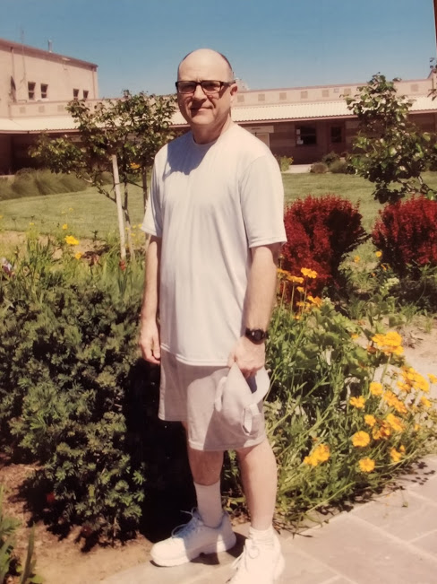

My name is James, Thanks for reading my profile. I enjoy meeting people from ALL OVER. I grew up in rural Missouri. I joined the U.S. Marine Corps and was stationed at Camp Pendleton, California. I was deployed twice to the West Pacific and saw places I never thought I would see. Hong Kong at night is awesome and the Philippines are the greatest place on earth. After the marines, I lived in California for a time, then I moved to Indiana and attended Ball State University. In 2001, I traveled to China with a group from my University. I stood on the Great Wall on top of a mountain, it was incredible!!!!
Since my incarceration I have continued my education by correspondence and earned degrees in business, social and behavioral science, and a bachelor’s degree in general studies.
I attend the Veterans Support Group and self-help groups weekly. When I was free I enjoyed scuba diving, boating, movies, and travel. Now I enjoy reading magazines about scuba, boating, and traveling. I enjoy watching television shows about places around the world. I also enjoy Gotham, and Agents of Shield, Star Trek and Dr. Who re-runs. I have a very basic (old tech) tablet that has some music and I also have an MP3 player with mostly 80’s music and some current Pop music.
For exercise, I walk, do push up and pull ups, and go to a yoga class every week.
I would like to write people all over the US and the world. I am interested in learning about you and your part of the world. If you write me, I’ll write you.
Have a great day,

James

