reachingaprisoner.com
“A journey off 1000 miles begins with a single step….. (or a single email)”

Thomas Fuentes DOC#P30204 KVSP P.O. Box 5103 Delano, CA 9316
DOB: 11/19/1977
Gender: Male
Ethnic Background: Latino
Height: 5ft 6in
Weight: 155lbs.
Hair Color: Black
Eye Color: Carmel
Speaks and writes Spanish
Expected Release: 2027
Sexual Orientation: Straight
Looking to Write: ANYONE
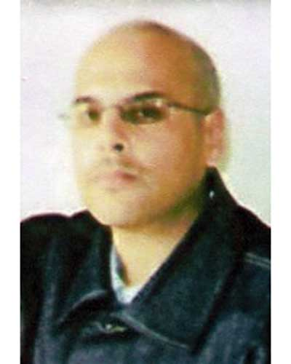

Hi there, my name is Tommy. I am single good-hearted down to earth California gent doing a little bit of time here at Delano.
I have placed this ad in hopes of meeting and making new friends online. Age, race, location, etc. do not matter. For me it’s where your heart and soul are at that counts.
If you can get past the fact that I am in prison, then I promise to get past you being a stranger. j.k. Hopefully we can swap some thoughts and smiles thru a few exchanged emails or snail mail possibly opening up the door to a nice friendship.
(or?)
About me? Well, I am sincere, respectful, caring and my mama says I’m handsome. I just like to think I’m old school cool in that I don’t have to fake it to make it. I have no hidden agenda none of those smooth Don Juan (player) lines that some guys are about. I’m not into games. There is nothing up my sleeves but my tattooed arms and sincere desire to get to know you.
Who knows? With some luck and magic sauce maybe we can become genuine friends?
I’m into music, movies (all genres) reality tv (the bachelor in paradise is a guilty pleasure) LOL I’m a glass half full type of guy. I’m optimistic positive and I have a sense of humor.
I don’t own a cape but do right when I can. My job in prison is a certified ADA caregiver. A job I plan to pursue post-prison. What else? I attend self help groups. I have no baggage, no bills, nor any bad habits. * (*that I am aware of ) I’ve been incarcerated for a while now, but I’m eligible for parole soon.
All of my options are wide open. “Today,” I’m looking for some genuine and legit people in the real world who I can share some sunshine with and maybe help to light my way as I continue in this journey and come to crossroads. For “today” is what truly matters. “Tomorrows” are never promised…. But always filled with promise. Thanks for considering me as your friend….
Email me direct @ Jpay.com (Tommy Fuentes P30204)
(or) email your first response to me here (indirectly)
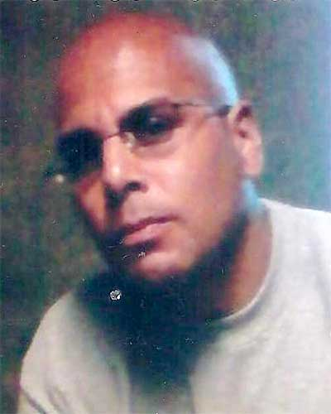
(or) snail mail works too!!!

Seize the moment for what it’s worth
Live your life from the day of birth
Cherish the moments don’t let go
May memories comfort you. Reach for the sky
Aim for the moon amongst stars you’ll fly
Share a smile. Share rays of sun
Due unto others, what youd like done
Pay it forward, live without regret
Be kind and considerate. Pay all of your debts
Don’t turn your back instead lend a hand
Never say “can’t” know you can
Life is to short live your life and say….
“I lived for the moment. I’ve seized the day!”
Tommy Fuentes
Carpe Diem

Sometimes
Sometimes I think about you Sometimes= all the time
Sometimes so much I think I’m losing my mind
Sometimes you touch my heart. Sometimes my soul
Sometimes I close my eyes and there you are
Sometimes right next to me even though truly far
Sometimes I fall asleep and drift into a dream
Sometimes I’m then with you and things are as they seem
Sometimes life is so funny you can’t help but laugh
Sometimes with you I forgot about the time that has passed
Sometimes “sometimes” gets sidelined given time and space.
Sometimes no longer, all the time in it’s place
All the time for you. All the time on the clock.
All the time is infinite. For you time simply…..
“Stops”
(A Poem for “Freedom)
Tommy Fuentes P30204
A Birthday Wish
As i send you this birthday wish
I wrap it in love and seal it with a kiss
my heart is included. Shipping is free
all because you mean so much to me
fireworks aren’t the only sparkle on this
special night
for the beauty exceeds and sparkle or light
if i could i would giveyou the earth
you deserve love and peace. this day of your birth
Happy Birthday my love. know that this much is true
there would be no happy birthdays without
sweet wonderful you.
Happy Birthday America (July 4, 1776)

Picture This
Picture me rolling. No, picture this
A perfect life. One filled with pure bliss
No shackles on our feet no ties that bind
Just peace and tranquility for our troubled mind
Picture a perfect place. “Yes” your own “Shang-ra-lai”
A perfect world, one that leaves you to awe
No walls surrounding us. Nobody telling us what to do
A land filled with bounty. Sky’s forever blue.
Picture a world where there is nothing but peace
Where all quarrels and wars, forever do cease.
A river runs thru it. Wash your troubles away
Deep cleanse your soul and find solace in the day.
Can you close your eyes and picture this land?
As someone reaches out to you
With their loving hands.
Picture This
By: Tommy P30204

