reachingaprisoner.com

Will Nolet DOC#174287 Little Sandy Correctional Center 505 Prisoner Connector Sandy Hook, KY 41171
DOB: 8/23/1976
Gender: Male
Ethnic Background: Caucasian
Height: 6ft 3in
Weight: 258lbs.
Hair Color: Brown
Eye Color: Brown
Expected Release: 11/18/2023
Sexual Orientation: Gay
Willing to Write: Anyone
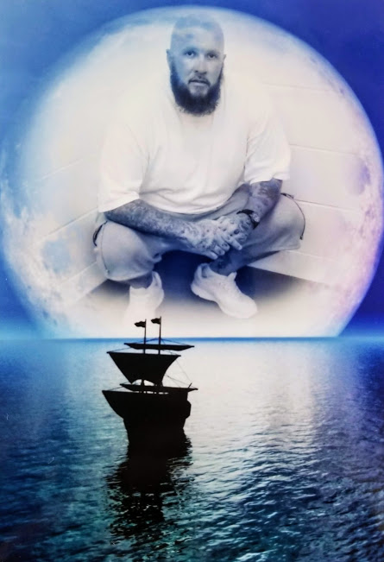

Hello, my name is Will, I’m 42 years young and a Virgo from Louisville, Kentucky. I stand 6 foot 3 inches tall, weighing in at 258 pounds with a stocky build, so yes, I am a big teddy bear! I have dark brown hair, but I keep my head shaved bald with a beard. I am heavily tattooed as you can see in my pictures. Now that I have my stats out of the way, and your attention let me tell you a little about myself. I am a PROUD gay man as you know from my profile info. I love the outdoors, camping, fishing, swimming, hunting and everything out doors. I love spending quality time with my partner. I love to cook inside and out, I enjoy walks in the park. I am an animal lover, so I enjoy the dog park as well. I also enjoy movies of all sorts, I enjoy comedy’s above all, I love to laugh and smile, music of all genre, I enjoy playing the drums and drawing. I am a football fanatic, so my Saturday’s and Sunday’s are spent watching the games during the season. I do have 2 daughter’s which are my pride and joy, and one on the way. I am looking to meet new friends, honest, loyal, down to earth people are a rarity these days. Honesty, and loyalty are a big deal to me in any friendship/relationship, like I said I am a big teddy bear with a huge heart. I f you are on this site you must be looking for someone or something in your life, take a chance and get to know me, and just maybe we can fill the void in one another’s lives. I promise you will not be disappointed! You can either write snail mail or JPay.com.
I hope to hear from you soon!!!

