reachingaprisoner.com
Hello, may name is Christopher Magnuson. I am 46 years old and I’m serving a 10-year sentence for theft. My release date is 4-6-2021. My occupation is I am a concrete finisher. I have been doing it for about 30 years off and on. I have tried other careers, but always went back to concrete. My accomplishments since being in prison: I have earned a barber license and I can tell you this much being bald myself, people don’t want a haircut by a bald barber. They’re afraid I only know a haircut bald. I have received critical thinking anger management and parenting certificates. I also teach a class on finding your inner self. I have a 21-year-old son that I am very proud of, he plays college basketball and majoring in sports medicine. I can honestly say I am a proud father. Relationships: Well, I have never been married, not because I don’t want to grow old somebody, it’s just I haven’t found the right woman I want to spend my life with, and I can assure you I’m not pick. The woman I am looking for is someone between 50 and 55, good sense of humor, open minded, not judgmental, like to travel, likes sports, football. Is willing to cook and clean with me, doesn’t mind big Sunday dinners and won’t get mad at me if I play XBOX Madden. A little about me; I’m compassionate, loving, a good listener, understanding, I like to cook and clean, I’m independent, I like riding Harley’s, fishing, boating, sports, traveling, family, I enjoy helping people and I believe everyone deserves a second chance at life. I enjoy reading my favorite authors are Greg Isles, Patricia Cornwell, Jon Grisham, and Jon Stafford. I don’t believe in arguing or shouting, it’s a waste of time and nothing gets accomplished. I have a sense of humor and I speak my mind. I care about people and how they feel. I don’t like a bully. I like children, I believe every child should go to a live sports game and catch a musky. I do not have a problem dating woman with children and I’m pretty funny. Well, I hope to hear from you soon.

Christopher Magnuson DOC#185729 MCF Oakpark Heights 5329 Osgood Ave Stillwater, MN 55082-1117
DOB: 12/24/1972
Gender: Male
Ethnic Background: White and Irish
Height: 5ft 11in
Weight: 240lbs.
Hair Color: Bald
Eye Color: Hazel
Expected Release: 4/6/2021
Looking to Write: Straight Woman
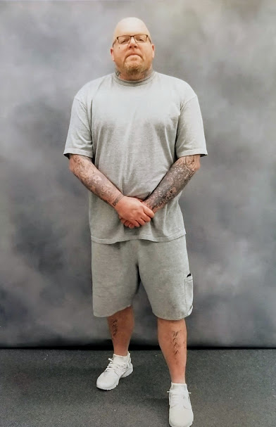

Christopher Magnuson

