reachingaprisoner.com
Hello and thank you for spending a little time out of your busy day to learn a little about me. I am adventurous and curious, and I have a need to meet new people and learn new things.
Brian Lee Fowler DOC# T26803
D17-B-206
Mule Creek Complex
4001 Highway 104
Ione, CA 95640

Gender: Male

Age: 48

Height: 5ft 8in

Weight: 185lbs

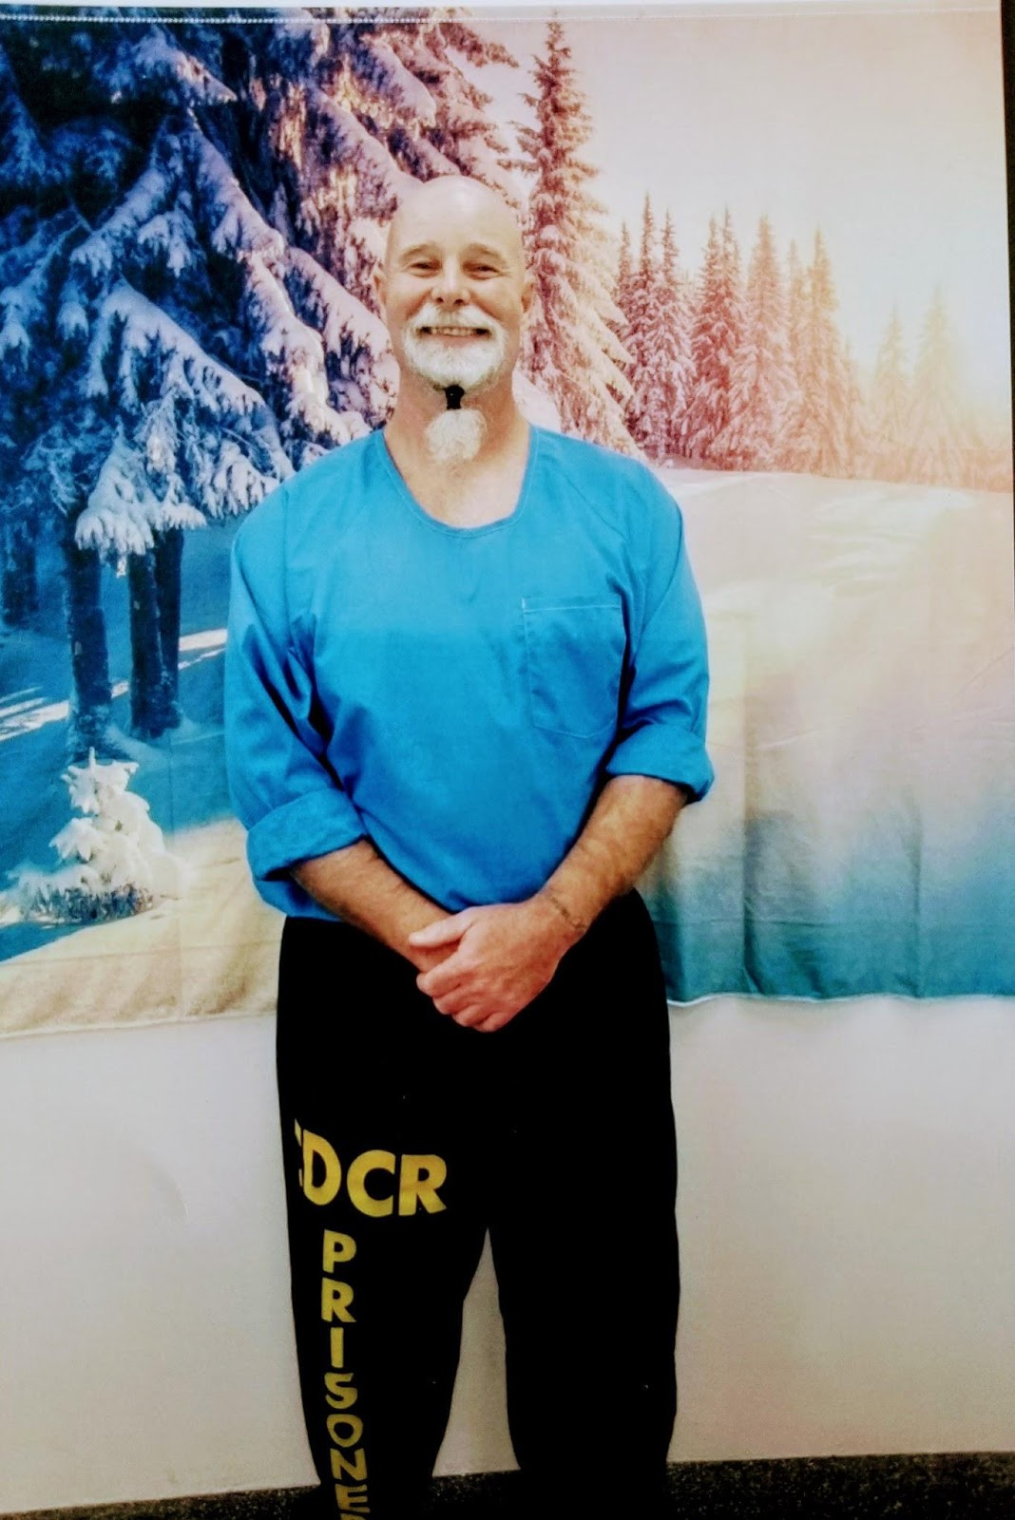

I am a down to earth and old fashioned. I have a good sense of humor and I like to make my friends laugh.
I am an Electrician by trade, and I like to work on Hot Rod Vehicles for a hobby. I actually fixed up a 1984 Pontiac Trans AM, Knight Rider “Kitt”, remember that one. I am looking forward to one day fixing up a 1967 Chevelle Malibu that my dream car.
I am 5 feet 8, I weigh 185 pounds. I am very active and play a lot of sports. I like all kinds of music and genres.
I like to watch a good movie with family or with that special someone. I am family-oriented kind of guy, and I am one who feels that the man brings home the bacon. I also feel that the man takes care of the women when they are under the weather.
I am a man’s man, but I also love to smell the roses when I walk past a rose bush. I am a sunrise and sunset kind of guy. I don’t want you to think I am a softy. I do like to go exploring, fishing, and I love the outdoors.
I playfully started a food fight one time with a lady, who I must add did not appreciate it, at first.
Anywho, please stay safe, and if you find you are fun and a little adventurous, please reach out and say Hi!

Respectfully,
Brian

