reachingaprisoner.com
Hey You!!!

Raymond Taylor DOC#89004 Tonopah Conservation Camp P.O. Box 8045 Tonopah, NV 89049
DOB: 5/9/1969
Gender: Male
Ethnic Background: African American
Height: 6ft. 2in.
Weight: 225lbs.
Hair Color: Black
Eye Color: Brown
Expected Release: 2021
Sexual Orientation: Straight
Looking to Write: Woman
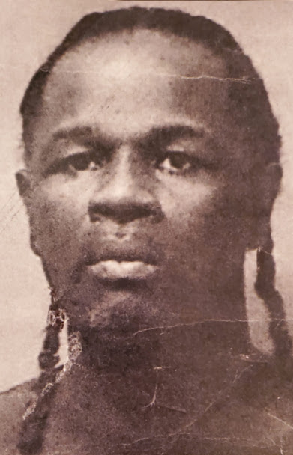

I’ll be brief, but ever real in my effort to reach “Her” thru this form/ad, note! I’m “Him” are you “Her”? Time is of the essence and my space is limited so I’m in need be concise in my approach (bear with me). I’m my mother’s son first and all else second. I’m a Taurus, I’m dark in complexion and my personality is a driven one; in that I’m ambitious in the higher order!
I’m looking for a woman to complement my successful nature and boost and support perpetual focus to achieve, is that you? I’m direct, are you special? I’m bold, are you dutiful? I’m with it, are you about it? I’m not a time waster, are you a choice maker? (Reply if you are).
I’m “Him”, are you ready to be “Her”?
Bye,
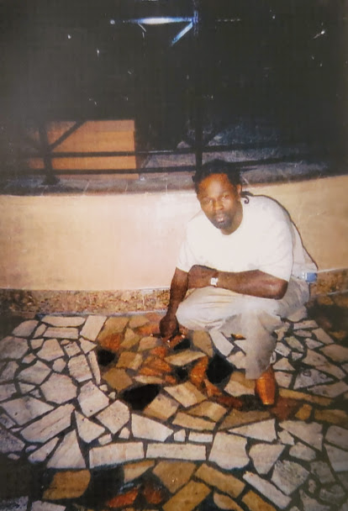
“Him”
