reqachingaprisoner.com
Hey World,

Andre Bowyer DOC#32816-058 FCI Mendota P.O. Box 9 Mendota, CA 93640
DOB: 9/8/1990
Gender: Male
Ethnic Background: Jamaican
Height: 5ft 11in
Weight: 176lbs.
Hair Color: Black
Eye Color: Brown
Expected Release: 11/23/2021
Sexual Orientation: Straight
Looking to Write: Straight or Bisexual Woman
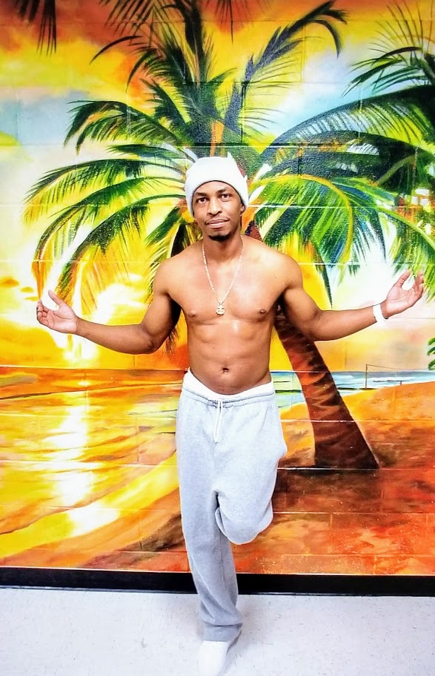

My name is Andre. I’m 5’11’, 28 years old. I used to be a skinny guy but started working out so now I’m 175lbs. of mostly muscle. I don’t really have much body fat. I don’t smoke or do drugs. I drink on occasions, but I’m not an alcoholic, neither do I have a drinking problem.
With that said, I am not a square. LOL and I am Jamaican, so I have no problems with someone doing/having any of the this I have listed. I like going to the movies, parks, beaches, anywhere that has new and exciting things.
As previously stated, I am Jamaican and have never been outside my country except to come3 to America and was arrested that same day, so I have not experienced any other cultures but mine. So, if you are reading this and are interested then maybe I can share my culture with you, and you share yours with me; who knows maybe we will become close friends or more.
I’m not a picky or superficial person. I don’t really care about age, height, weight, race, etc. I’ve been raised not to see a person for what they look like but who they are inside. So, if you are kind, caring, honest, loyal, ambitious, and driven then we will get along just fine because that is the type of person I am. So, shoot me a letter and we can talk more.
