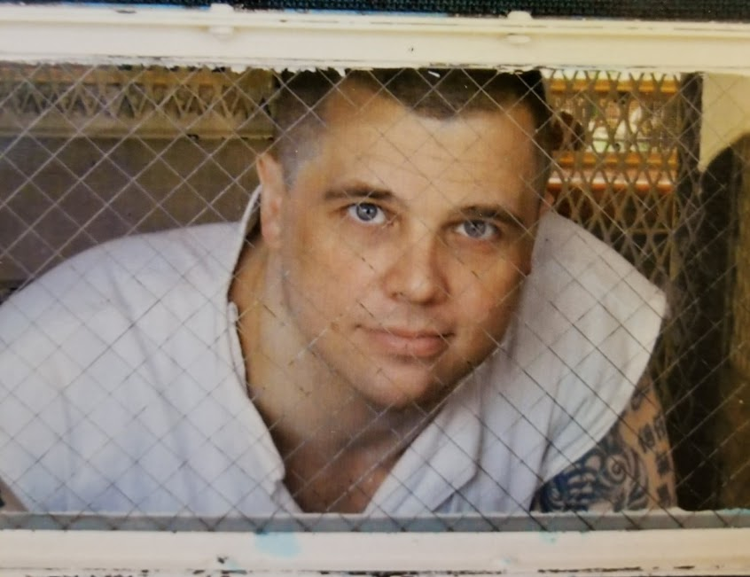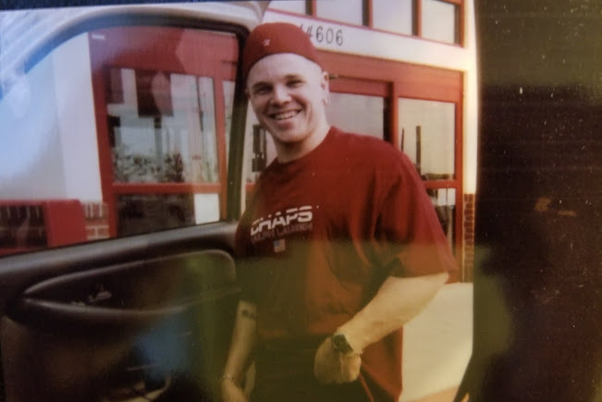
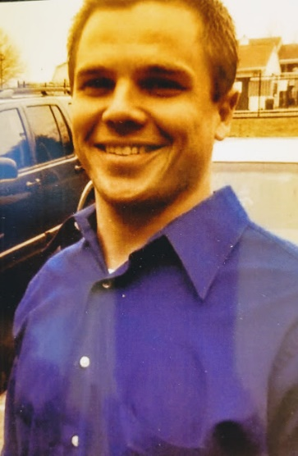
Phillip E. Boldon DOC# 1786854
Ellis Unit
1697 FM 980
Huntsville, Tx 77343

Hello World,
My name is Phil and I am 39 years old. I am 5’8, 180 pounds with brown hair and blue eyes and I have a quite a few tattoos. Born and raised in Huston, TX. I am currently serving and appealing a life sentence (30 years) on a murder charge. I know it may sound horrible, it’s terrible anytime someone loses a life.
All I ask is that you keep an open mind and get to know me for who I truly am before making a judgement of your own. Growing up I dreamed of playing professional basketball and having a family of my own. After graduating high school, I accepted a full scholarship to play baseball at the University of Texas.
That’s where I meet Rhonda, the women who changed my life forever. She and I “clicked” almost immediately. WE had gotten engaged and she was 3 months pregnant when she was killed in a horrible car accident.
I lost all control, began drinking heavily and experimenting with different drugs while trying to escape the pain I was burying myself within me. I couldn’t deal with the memories she and I had around campus, so I gave up me scholarship and moved back to Huston.
I can’t get into specifics about my case with it being in appeal, but I had gotten involved way over my head in a drug world never fully understood with some associates that left a lot to be desired in the morals and integrity department. Which all led to my current situation.
I am very outgoing, with a great sense of humor and a passion to reach out and help prevent others from choosing the same rough paths I chose. Looking for someone I can write and establish a true friendship; age race is of no importance. If you are real and interested in writing, I’d love to hear from you.
Respectfully,
Phil

