reachingaprisoner.com
Hi, my name is Tray. I’m setting up this pen pal service looking for a nice friendship to build with. I am looking for a friend that is honest, like myself. Someone who’s beauty inside outshines the sun.

Tray Ferguson DOC#33855044 Coleman 1-USP (F-Unit-208) P.O. Box 1033 Orlando, FL 33521
DOB: 1/22/1983
Gender: Male
Height: 5ft 7in
Weight: 160lbs
Hair Color: Black
Eye Color: Brown
Expected Release: 2028
Sexual Orientation: Straight
Looking to Write: Woman
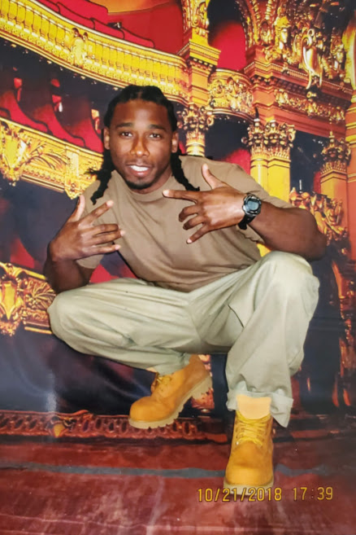

About me, I am from St. Louis, MO. I am 36 years old, 5ft 7in., 160 lbs., brown skin, brown eyes, and black hair. I am into wellness and take care of myself. I love my family, I like to laugh, have fun, like to read good books, and watch good movies. My favorite movie is “The First Friday” While incarcerated I take every program and trade that is offered. I enjoy helping others, teaching them when they are willing to learn. Trust me I am one of the perfect friends a person can have. I am a good person locked up for being in the wrong place at the wrong time. I look forward to hearing from you.
Sincerely yours,
Tray

