reachingaprisoner.com
Attention Fun Seekers!!!!!!

Wayne Black DOC#31844 SAWC (Cell 37) 125 N 8th West St. St. Anthony, Idaho 83445
DOB: 11/28/1963
Gender: Male
Ethnic Background: White
Height: 6ft.
Hair Color: Blonde
Eye Color: Blue
Expected Release: 2020
Sexual Orientation: Straight
Looking to Write: Woman
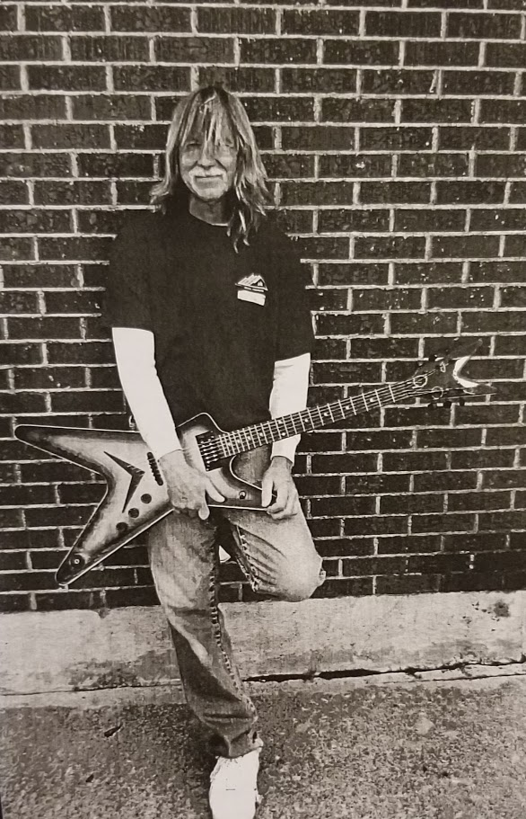

My name is Wayne and I play, teach, and write guitar music. I love to fish, Mountain bike and I’m also a chef. I’m looking for someone who loves to laugh, have a good time doing. Whatever it is, I just like to keep things positive. I top out my sentence next year which means no parole. I’m free from the Boise area and I’m eager to hear from you! For more info just write and let’s get to know each other. You can reach me on JPay or snail mail. Have a wonderful day!!!
