Reachingaprisoner.com
Hello,

Trisha Johnson DOC# WF7492 C.C.W.F (509-21-3W) P.O. Box 1508 Chowchilla, CA 93610
DOB: 2/29/1992
Gender: Female
Ethnic Background: African American
Height: 5Ft. 7in.
Hair Color: Brown
Eye Color: Brown
Expected Release: 1/15/2020
Looking to Write: ANYONE
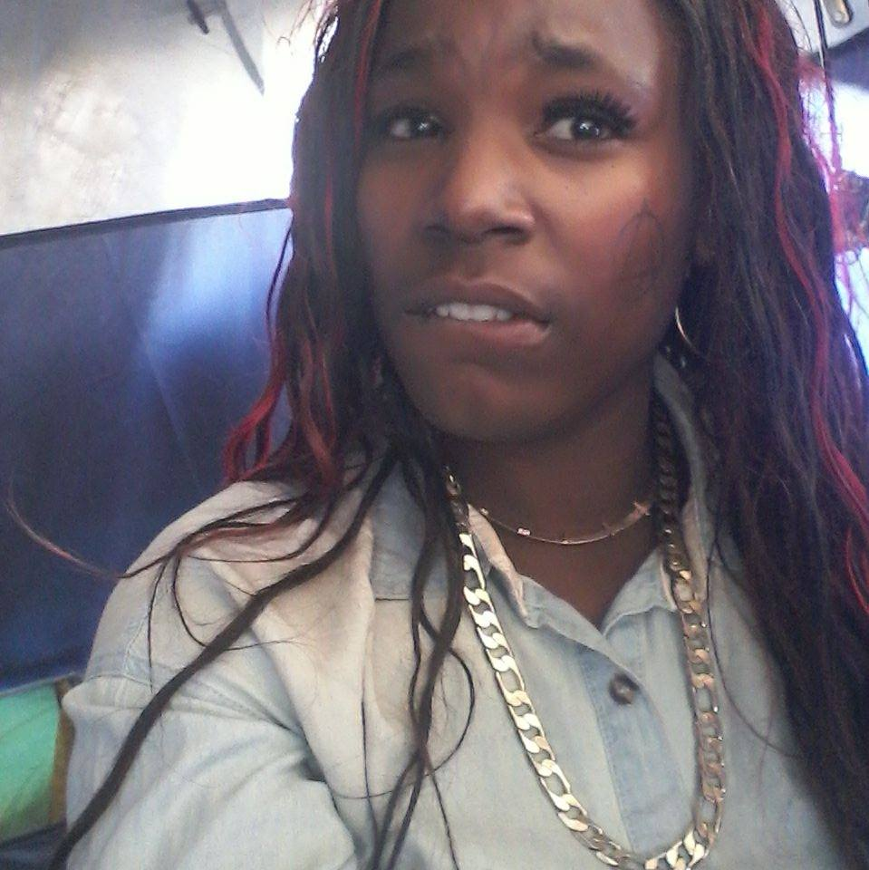

My name is Trisha Johnson. I am interested on finding someone that is respectful and supportive also non-judgmental. I’m a very easy person to get along with. I consider myself loyal, openminded, I enjoy the outdoors, music, reading, romantic books, long walks on the beach and nature. Since I’ve been incarcerated; I have attended a lot of self-help groups to help me better myself. Well, if I seem like the type of person that you would mind getting to know and becoming friends with. I’m here writing on you.
