reachingaprisoner.com

Cedrick Roman Diggs F.B.O.P. Springfield P.O. Box 4000 Springfield, MO 65801
D.O.B: 10/13/1970
Gender: Male
Ethnic Background: African American/Black
Height: 6ft. 1in.
Weight: 260lbs.
Hair Color: Black
Eye Color: Black
Expected Release: 4/1/2054
Sexual Orientation: Straight
Looking to Write: Females
Has access to Corlinks
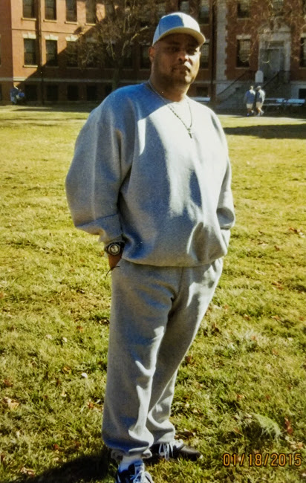

My name is Cedric Diggs and I am from your future. I can see and have a sense of humor and being able to laugh and enjoy life in spite of trials is important. Though I am not really from the future (surprise!) my mind is focused on it. I am overcoming the mistakes and bad decisions of my past and pursuing my purpose. I am a God fearing, open-minded, business savvy, straightforward, charismatic person with a touch of shyness mixed in.
I’m looking for a God-fearing, independent, down to earth, strong woman with a sense of humor and a little feistiness to go with it. I love to talk, but more than that, I know the value of being a good listener. I seek to show compassion and understanding the point of view of others. I’m not perfect, but who is? I’m just a man. The process of change, building my future and looking to build a friendship. After that……only God knows, but I’m open to the future.
