reachingaprisoner.com
Hello, I am Meka. I’m in search of a special friend. Someone that I can build a real and meaningful friendship with. I’m interested in intelligent, educated and respectful men.

Temeka Mason DOC#454296 Tperl Room 60 Patuxent Institution P.O. Box 700 Jessup, MD 20794
DOB: 6/4/1977
Gender: Female
Ethnic Background: African American
Height: 5ft 5in
Weight: 185lbs.
Hair Color: Brown
Eye Color: Brown
Expected Release: August 2020
Looking to Write: Men
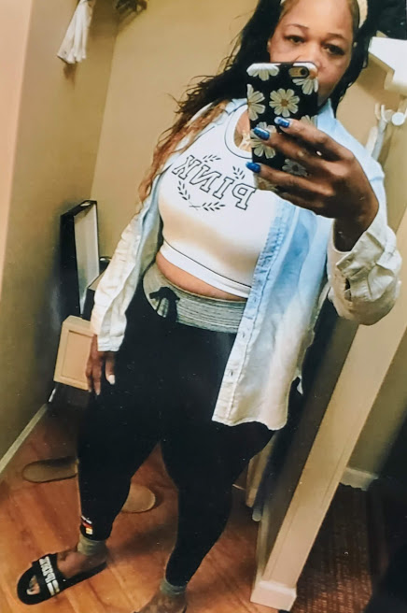

To tell you a little about me. I love the Lord. I also love to travel, exercise, cooking, shopping, and learning new things. Caring for others has always been my passion. I don’t want to be judged by my past mistakes. Our mistakes in life are lessons. I’m not perfect by heart is. I hope to hear from you soon.
