reachingaprisoner.com
When special people touch our lives then suddenly, we see beautiful and wonderful our world can truly be. They show us that our special hopes and dreams can take us far, by helping us look inward and believe in who we are. They bless us with their love and joy through everything they give. When special people touch our lives, they teach us how to live. Hello Lady’s, I thought I’d start off with a few words I find to be true. Now allow me to satisfy your curiosity and share a few things about myself. I am a proud Native American man who lives by respect, honor and loyalty. I’m a real kick back guy who likes to laugh and have fun. I’ve always been one to live life to the fullest so with that come many experiences. I was born in Arizona but lived in Colorado, New Mexico, and Texas. I enjoy watching football and UFC. Movies I’d rather laugh over all other movies. I like to read books on native culture and customs. I also like books that help better myself. I like all music, but I am drawn to slow jams. I was raised on oldies, so they take me back to a happier time. I’m looking for a long-term friend who likes to laugh, but most of all I’m just excited to meet you ladies from all walks of life, and I know letters can be awkward especially in times of new beginnings. So, I wrote this in hope that you will find something of interest to you and feel the urge to respond, and just maybe over time you’ll come to see the true definition of friendship can be discover within me…..

Gabriel Roy Burns DOC#249135 Eyman/Browning Unit P.O. Box 3400 Florence, AZ 85132
DOB: 9/12/1986
Gender: Male
Ethnic Background: Native American
Height: 6ft
Weight: 280lbs.
Hair Color: Black
Eye Color: Brown
Expected Release: 7/31/2033
Sexual Orientation: Straight
Looking to Write: Woman
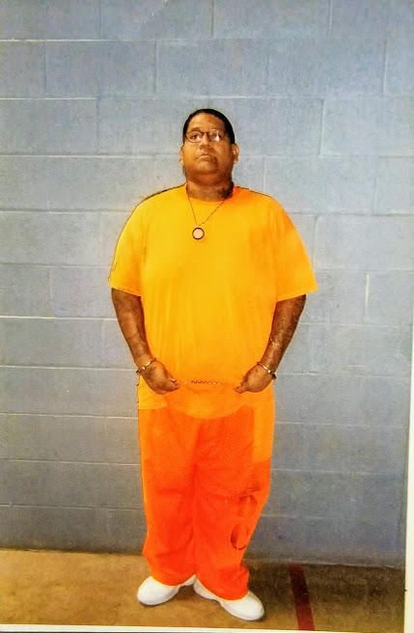

Respectfully Your New Friend!!!

