reachingaprisoner.com

Asia Foster DOC#1559826 Fluvanna Correctional Center P.O. Box 1000 Troy, VA 22974
DOB: 7/13/1992
Gender: Female
Ethnic Background: African American/Black
Height: 5ft. 6in.
Weight: 133Lbs.
Hair Color: Brown
Eye Color: Brown
Expected Release: 8/21/2028
Sexual Orientation: Straight
Looking to Write: Straight Men
Has access to: JPay
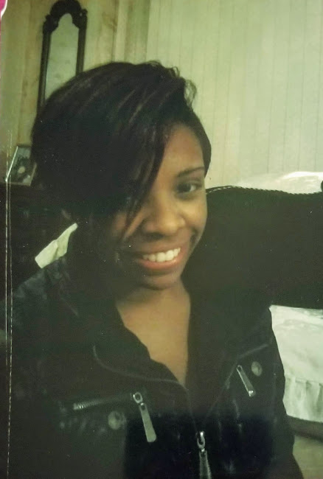

Hello Everyone!
My name is Asia and I am 26 years old. I am originally from Illinois but relocated to Virgina in 2013. Unfortunately, I got into some major criminal trouble and was sentenced to do 15 years in the Virgina State Prison. Since I have been incarcerated I’ve maintained employment, been taking correspondence, trade and college courses. Adding to that I’ve bee attending many mental health groups to help me maintain a healthy mental stability, in here. I am working hard to obtain my associates degree in general studies, my HVAC certification and my paralegal certification. Even though, I’m incarcerated I am not going to let this situation stop me from being all that God created me to be. I stay to myself most of the time, so I won’t lose focus on what I need to do to rehabilitee myself. I have high hopes for my future even though, I’m living in darkness currently, but there is light at the end of the tunnel. I am a friendly person and I enjoy meeting new people. I’ve joined Reaching a Prisoner because I want to meet more people that will encourage, motivate and uplift me during this very difficult time. It gets pretty lonely in here. And I miss talking to people out in the free world. I am looking for general conversation, honestly. If you are interested, please feel free to write me at the address listed on my profile. I look forward to hearing from you!

