reachingaprisoner.com
Hi:

Eugene Lorenzo Wilson#187659 Wisconsin Secure Program Facility P.O. Box 1000 Boscobel, WI 53805
DOB: 7/21/1963
Gender: Male
Ethnic Background: African American
Height: 5ft 7in.
WEIGHT: 175LBS.
Hair Color: Black
Eye Color: Brown
Expected Release: November 2021 early release
Sexual Orientation: Heterosexual
Looking to Write: Straight Woman Only
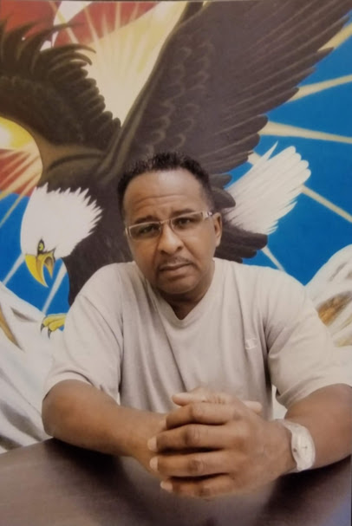

My name is Lorenzo. My friends call me “Zo.” I’m a mature, single, soon-2-be-released, man who’s looking forward 2 making a difference in the lives of others upon my release. Since the beginning of my incarceration I have worked very hard to become a better man and change my path life has brought me 2 prison. In 2008, I enrolled in college courses in Law and latter entered my Certification as a Paralegal and as an Academic Tutor.
Currently, I’m enrolled in Business and Real Estate courses, and studying 2 obtain my Advanced Certification in Paralegal Studies from Adams State University. In my spare time I provide legal assistance 2 prisoners throughout Wisconsin, I mentor men at the prison in developing their Coping and Positive Decision-Making skills and preparing for their reentry into society. So far, I’ve taught over 150 men how to read and write and helped 125 men study for and obtain their GED’s.
It took coming 2 prison 2 open my eyes and my heart 2 the inherit values in being of service 2 others. So, upon my release I’ll start my own Paralegal Law Firm that will provide legal assistance to the poor in the areas I feel are important; like childhood hunger, homelessness and the civil rights of the underprivileged. I’d also like 2 start a group home for At-Risk teens so they don’t end up in prison like I did.
I enjoy old school R&B, Hip-Hop, and Country music, meeting new people, dancing, Karaoke, cooking, and watching movies. I would like to exchange emails and letters on a friendship basis with open-minded and compassionate woman between 40 & 60 years old.
I’m not judgmental, so your race and waist size is not an issue. Unlike most men, I don’t believe a woman is any less desirable because she was “BLESSED” to be a size 12 or 20. I think Big, Beautiful, Woman (e.g.; Kim Gravel; Oprah (B4 Weight Watchers), or Lizzo)are very attractive, and I’ve come to realize that “true beauty” is not what’s on the outside of a woman, because outward looks fade with time, but the inner beauty of a woman, because of a woman whose personality demonstrates her patience, compassion for others, and her personal integrity, gives that woman a glow of beauty that no cosmetics in the world could ever duplicate.
If you can understand what kind of man I am, I’d like 2 meet you and maybe be your pen-pal.
Zo
