reachingaprisoner.com
I’m a wonderful friendly warm person who would like to be with friends, full of fun and love, caring and never forget tight hugs…I cherish the moments I share with everyone, respectful and get along really well with everybody, a person who have soft and open heart for everyone….who never care about what they are or what they do….I see them as a good people until they show me otherwise, everybody’s friend.

Baha’eddin Al Momani DOC#S14377 Western Illinois Correctional Center 2500 Rt. 99 South Mt. Sterling, IL 62353
DOB: 1/1/1977
Gender: Male
Ethnic Background: Arab-Middle Eastern
Religion: Islam-Muslim
Conviction: Aggravated Sexual Assault/ Kidnapping
Expected Release: 2040
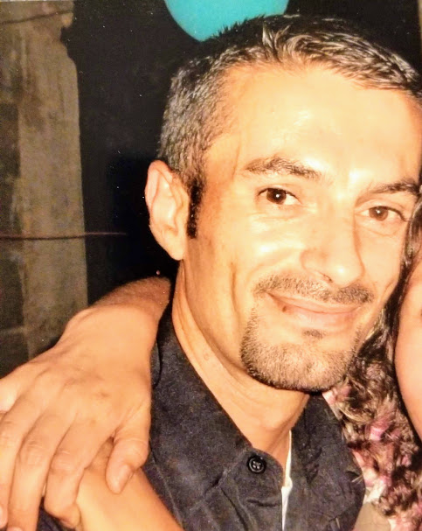

I’m a giver…I give and give till I have nothing to give…If I have the last dollar in my pocket, I’d give it to you, I always have something good to give…I’m the one who would give you the coat when your cold.
I have an outgoing personality, sweet and kind with beautiful demeanor, well respected and so respectful to others. Love to set down and have a nice conversation with anybody, whether I know them or not. Free sprit and try my best to do the best to make friends that are proud of me.
People who know me describe me as “as a cool person that listens, is helpful, and funny.” But you’re a Godly person and follows rules from where you come from “Jordan”, A person who have a lot of love in one person, full of energy… you smile no matter what’s your mood….emotional and compassionate to people, bubbly, jokes with everybody…and good with keeping in touch with everyone.
I love to travel, I have had a chance to travel all over the U.S. and meet so many nice people.
I love to teach, and my wish is to get a chance to help children here and other countries by improving their school’s education
My hobbies: photography, art painting, reading, sports (soccer). At the end, I thank everyone of you for reaching out to prisoners and make a difference in our lives…
I believe God puts every person we need in our way and God has a plan for each of us to shine our darkness…God planned you, choose you to heal a prisoner’s heart. We all pray for you, for passion and kindness in your heart.
