Reachingaprisoner.com
Hi, my name is Marvin, please allow me to tell you about myself and things I like to do. First, I enjoy fishing, camping and the beach. I also enjoy planting roses and other plants, I am a God loving person, sure I’ve made some mistakes in life, I can’t change that past, but I can the future. I hope that you can be a part of my future. I hope you can be part of my future.

Marvin Roberts DOC#15547761 OSP A115B 2605 State St. Salem, OR 97310
DOB: 4/27/1962
Gender: Male
Ethnic Background: White
Height: 6ft. 1in.
Weight: 240lbs.
Hair Color: Brown
Eye Color: Brown
Expected Release: 4/17/2021
Sexual Orientation: Straight
Looking to Write: Female’s Straight or Bisexual
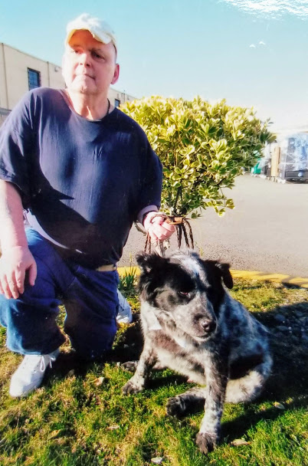

We have a prison dog here who I just playing with, to be honest, he makes my day. My job here in the prison is working in the laundry, I am a jack of all trades, so I do just about everything. Did I say I am a hard worker? I enjoy my job, being it keeps me very busy; it also helps keeping me from being lonely.
I will answer all who writes me, so get that letter in the mail, so we can become friends. Thank you for reading my ad, I am hoping to get your letter soon. Thanks again.
Bye,
Marvin
