reachingaprisoner.com
Dear you,

Cyrus Brooks DOC# 356758 Fox Lake Correctional Institute P.O. Box 200 Fox Lake, WI 53933
DOB: 9/6/1984
Gender: Male
Ethnic Background: African American
Height: 6ft 1in
Weight: 205lbs.
Hair Color: Black
Eye Color: Brown
Expected Release: 2042
Looking to Write: Woman
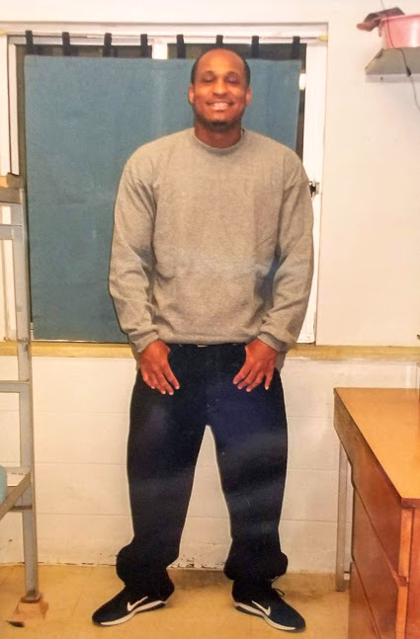

I’m just looking for a friend to help me win this fight against all odds in this thing we call life. I feel like I have nothing to lose, but everything to gain by being sincere on what I’m looking for. I want to do what most men don’t want to do and that is take the time out to learn about you. There is always risk with anything we do in life but without risk there is are no rewards, so let’s risk this together. I figured we could be each other’s outlet, release therapy and support cast.
I grew up running the street at an early age which led me into the system; detention centers and group homes. I’m from Milwaukee, WI. I have no kids, I’m finished with school and I completed a vocation through Madison Technical College, for custodial services. I also currently have an appeal pending so my story if far from over.
Feel free to learn more about me and maybe we can make some new chapters together. The color of your skin holds no weight, because I am color blind, but the complexion of your heart speaks volumes and the texture of your mind means everything. I refuse to let my situation define who I am as a man. Please don’t judge me, but feel free to ask me any personal questions that come to mind. I take pride in being the living definition of everything a means to me, so I’ll take pride in being everything you need from me for you, even if that means just a good friend.
I guess some of my strengths are also my weaknesses. For example; I am loyal, loving, and caring. If you feel some type of vibe don’t be shy to let your hair down.
