reachingaprisoner.com
Hello,

Hakim Williams DOC# 150087 MCF-Rush City 7600 525th Street Rush City, MN 55069
DOB: 8/31/1973
Gender: Male
Height 5ft. 6in.
Weight: 179lbs.
Hair Colo: Black
Eye Color: Brown
Expected Release: 2023
Looking to Write: Straight or Bisexual Woman
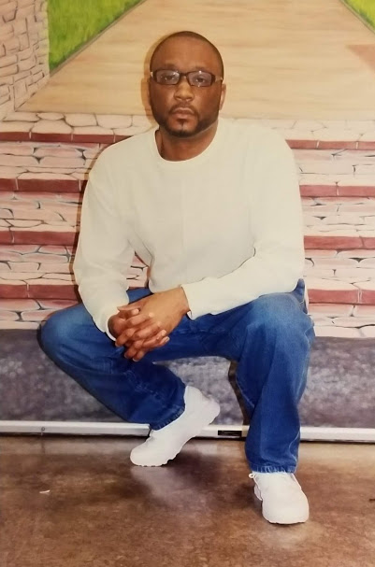

My name is Haim and I have been incarcerated for 22 ½ years and have 4 ½ years left. I am on a mission to find an older woman that has class. That is loving, caring, loyal, honest and can be understanding. I don’t care about looks, size or race, but your heart is more important.
Here is a little more info about me: I love to work out, I love to read, I love to write emails. I love to take pictures. You can write me at WWW.JPay.com.
