Reachingaprisoner.com
Hello Ladies,

Adrian Butler#42453007 Allenwood USP (2A/Cell 122) P.O. Box 3000 White Deer, PA 17887
DOB: 2/20/1973
Gender: Male
Height: 5ft 5in
Weight: 150lbs.
Hair Color: Black
Eye Color: Brown
Expected Release: 4/21/21
Sexual Orientation: Straight
Looking to Write: Woman
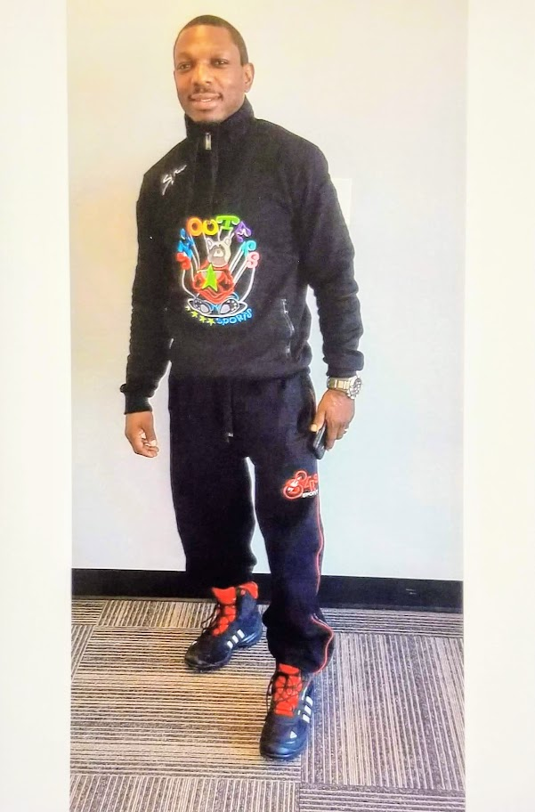

I stand at 5 foot 5 inches tall with a weight of 150lbs. My skin complexion is brown as well as my eyes. I have short black wavy hair. My physique is muscular build. I am interested in meeting someone who wouldn’t mind taking the time to get to know me as I get to know them. I have a great sense of humor, very patient, peaceful, humble, loving, thoughtful and passionate. I am ambitious, confident, but not cocky, spontaneous, but most importunately I’m genuine and honest.
Here are a couple things I love to do are cooking, traveling, reading, working-out, family gatherings, outside events, and dancing. I am a person who appreciates and enjoys the little things that a person has to offer, as well as the big things. I am equally satisfied with a quiet evening inside enjoying very equally satisfied with a quiet evening inside enjoying each other’s company whether it’s talking or just cuddling while watching movies.
Since being incarcerated I have completed a list of courses like flagger trainer, stock market, business development, government civics, CDL training, and many more. I feel has expired my versatility and my education and employment options once I’m released.
After reading this, if you find anything about me interesting and you are curious to know more, please feel free to contact me. I look forward to ug getting to know one another.
