reachingaprisoner.com
Leonard Hawkins DOC#1144730 Coffeewood Correctional Center P.O. Box 500 Mitchells, VA 22729
DOB: 11/20/1957
Male
Ethnic Background: African American/ Black
Height: 6ft.
Weight: 225
Hair Color: Black
Eye Color: Green
Expected Release Date: 9/19/2019
Sexual Orientation: Straight
Wanting to Write: Anyone/Females
Has access to JPay
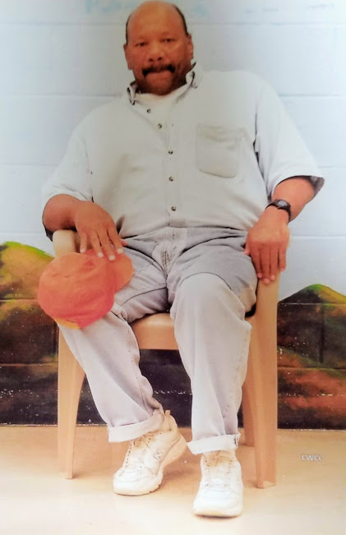

“PSST PSST, CAN WE TALK”
Hi, I’m Leonard, 60 years old, 6ft at 225 lbs. I am an honest, thoughtful, sincere, uplifting, optimistic and very loyal Gentleman! With a child like faith; I still believe in wishing upon falling stars and pursuing the end of the end of a rainbow. So, like a dandelion, I blow to the gentle breeze seeds of HOPE and PRAYERS, to welcome someone into my life to embark upon the journey of true friendship!
To be honest and with great remorse I committed a few robberies in the 1980’s and will be finally released in June of next year 2019. Since then I’ve strived in due diligence to rehabilitate myself each day educationally, vocationally, religiously, and self-help programs to enhance my qualities as a GOOD MAN! I’m a God-fearing man and RISE like a beacon of light in hopes of meeting a mature, charming, receptive, honest, bubbly middle aged women for a conversation and friendship.
Therefore, I offer YOU my genuine kindness, respect, wisdom, support, strength, ear, heart and many smiles. Let’s discuss the possibilities I’m only a stamp away (we’ll email later). I cross my heart to respond to ANYONE who writes me!
