5reachingaprisoner.com
Hello Ladies,

Thomas J. Owens, Jr. DOC#2106366 Wayne Unit 810 F.M. 2821 Huntsville, Tx 77349
DOB: 6/20/1982
Gender: Male
Ethnic Background: African American
Height: 6ft 1in
Weight: 210lbs.
Hair Color: Black
Eye Color: Brown
Expected Release: 9/2020
Sexual Orientation: Straight
Looking to Write: Straight and Bisexual Woman
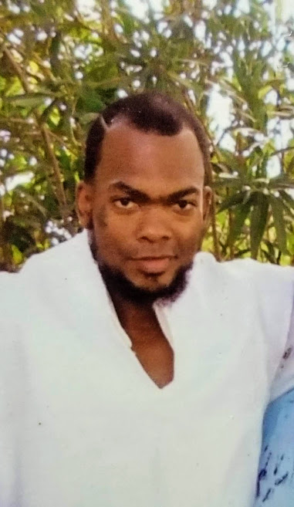

My name is Thomas Owens, but I go by “Latif” which means “Subtly Kind”, it’s my Muslim attribute. I’m 36 years-young, I’m 4RM Dat Big Easy, know as New Orleans, LA. But (God Willin) upon my release I’ll be residing in Huston, TX. I love and fear God (Allah)! I am very conscious, kind, ambitious, humorous, sentimental, out going alpha-male, I’m a Gemini, so I’m Intune with humanity (LOL)! I’m looking for a good woman to build a friendship with and possibly more! I like an ambitious woman, who knows what she wants out of life, including short- and long-term realistic goals dat she wants 2 achieve! I’m not who is bias 2 one’s religious preference, neither am I one 2 look down on anyone’s past. I love woman of al races, especially one who is not only beautiful externally but also internally! I really KUT 4 a woman who is (thick) portioned in all the right places, I love short woman since I’m tall, but would love 2 hook up with a woman who is tall as well! I exercise daily because it’s healthy and a good stress reliever, I love 2 watch and play sports, (my favorite is football), so of course the Saints is my favorite team and the Patriots are my 2nd team. I love to read and write another stress reliever, I read a lot of self-help books, love novels, Forbes, GQ, Entrepreneur type magazines (God Willin) I plan on owning a variety of business, my ultimate goal is 2 start my own non-profit Organization 4 poverty stricken kids from all walks of life with an attempt to detour them from the bad choices I chose in my past! I love 2 cook, so a creole/Cajun restaurant is on the forecast (God Willin) I’m currently enrolled in college striving 2 obtain my associates degree in business! I love music, I can’t live without it! I’m N2 Hip-Hop, but my preference is rhythm and blues and Oldies but goodies! My favorite artists are Anthony Hamiliton, Antia Baker, Luther Vandross, Avant, Case, Gerald Lewert, Keith Sweat, Lyfe Jennings, Jahiem, Al Green, Marrwin Gaye, Future, Jay-Z, Post Molone, Alicia Keys, Monica, Kelly Price, Jagged Edge, 2 Pac, Juvenile, Mack Millz, Kevin Gates, Young Thug, Ella May, Frankie Beverly, Keisha Cole, Jadakiss and the list goes on! I’m looking 4ward 2 vibin with some down 2 earth, beautiful intellectual women from all different walks of life, who want 2 build with a handsome gentleman like myself! Good Bless, See ya soon!
